The Gulf Coast Center/Connect Transit
4352 E.F. Lowry Expressway
Texas City, Texas 77591

Request for Qualifications 2021 TRANSIT 001

Professional design Services for Public Transit Provider

Issue Request for Qualifications: December 18, 2020
Deadline for Written Questions: January 6, 2021
Issue Responses to Questions/Final Addendum: January 8, 2021
Qualifications Closing Date & Time: January 15, 2021, 1:00 p.m. CDT

Contact
Luis Diaz, Gulf Coast Center Asset Director
luisd@gulfcoastcenter.org
(409) 944-4344

Table of Contents
Submittal Checklist 4
Part I – Notice for Publication 5
Notice 5
Schedule 5
Questions 5
Part II – Instructions to Proposers 6
1. Introduction 6
2. Qualifications Requirements 6
3. Statement of Qualifications format 8
3.1. Executive Summary 8
3.2. Experience 8
3.3. Approach 8
3.4. Staff 8
3.5. Other Required Information 8
4. Terms 9
5. Questions 9
6. Other Communication 9
7. Unsolicited Communication 9
8. Qualifications Due Date and Time 9
Part III – Scope of Work 10
1. Overview 10
2. Scope of Services 10
Part IV – Laws, Regulations, and Mandatory Requirements 12
1. Funding: 12
2. Laws, Permits and Licenses 12
3. Center Business Code of Conduct 12
4. Conflict of Interest 12
5. Federally Requireed Contract Clauses 12
6. Assignment 13
7. Delinquent State Business Tax 13
8. Procurement Priniciples and Standards of Conduct 13
9. Disadvantaged Business Enterprise (DBE) and Small Business Enterprise (SBE) 13
10. Indemnification 14
11. Independent Contractor Relationship 14
12. Covenant against contingent fees: 14
Part V – General Conditions 15
1. Qualifications 15
2. Review and Evaluation Criteria 16
3. Protests 18
4. Contract 20
5. Invoicing 20
6. Payment 21
7. Non-Appropriation 21
Exhibit A – Minimum Insurance Requirements 22
Exhibit B – Gulf Coast Center Code of Conduct 24
Exhibit C – Conflict of Interest Questionnaire 32
Exhibit D – Federally Required Contract Clauses 34
Exhibit E – Respondent Pre-Award Certifications 45
Lobbying Certification Form 46
Suspension and Debarment Certification Form 47
Respondent/Contractor Certification Form 49
DBE and SBE Subcontractor Letter of Intent 50
Delinquent State Business Tax Certification Form 51
Certificate of Interested Parties 52
Senate Bill 252 Certification 53
House Bill 89 Verification 54
Contractor Payment Report Form 55
Exhibit F – TxDOT PTN 130 Form 56
ExhiBit G – Acknowledgment of Addenda 63
Exhibit H – Required Response Form 64

Submittal Checklist
For a detailed list of items needed for the submittal, please see Qualifications Requirements on Page 8.

Forms Included in this Request for Qualifications (RFQ) Needed for Submittal:
- Exhibit C, Conflict of Interest Questionnaire – Page 32
- Exhibit E, Respondent/Contractor Pre-Award Certifications – Page 45
- Exhibit F, TxDOT PTN 124 Form – Page 56
- Exhibit G, Acknowledgment of Addenda – Page 63
- Exhibit H, Respondent Information Form – Page 64

Respondent-provided Items Needed for Submittal:
- Title Page
- Letter of Transmittal
- Statement of Qualifications (See Statement of Qualifications Format for Details)
- Certificate of Insurance

Part I – Notice for Publication

Notice
Sealed Qualifications for Solicitation #2021-Transit-001 – Professional Design Services will be received by the Gulf Coast Center/Connect Transit (the “Center”), by mail or hand delivery until the Qualifications Due Date and Time at the location below. One (1) electronic version via email with qualifications documentation clearly identified must also be submitted.

Due: January 15, 2021 at 1:00 p.m. CDT

Gulf Coast Center/Connect Transit
4352 E.F. Lowry Expressway
Texas City, Texas 77591
E:mail: luisd@gulfcoastcenter.org

The RFQ will be available by December 18, 2020, and in electronic form at the following link: https://gulfcoastcenter.org/business-opportunities/.

Schedule
Issue Request for Qualifications | December 18, 2020
Deadline for Written Questions at 5:00 p.m. CDT  Questions shall be posted to website | January 6, 2021
Issue Response to Questions/Final Addendum  Responses shall be posted to website | January 8, 2021
Qualifications Due by 1:00 p.m. CDT | January 15, 2021
Award Contract to Successful Respondent | February 2021

The Center reserves the right to revise the above schedule. Notice of date changes, addenda to the procurement or the Center’s responses to questions will be posted to Connect Transit’s webpage at https://gulfcoastcenter.org/business-opportunities/.

Questions
All inquiries regarding this RFQ should be directed to:

Luis Diaz, Director of Fixed Assets and Purchasing
Email Address: luisd@gulfcoastcenter.org
Phone Number: (409) 944-4344
No late Qualifications shall be received by mail, phone, or fax. Respondents bear the risk of late delivery. Qualifications received after the deadline will be rejected.

Part II – Instructions to Proposers
- Introduction: The Gulf Coast Center, hereinafter “Center,” is seeking statements of interest and qualifications from professional service firms or teams to provide conceptual design, preliminary design, completion of any required engineering reports, survey, design development, final design, landscape architecture, geotechnical, materials testing, permitting, and bid and construction phase services for transit-based projects for the Center. The Center invites interested professionals to submit Statements of Qualifications (SOQ) for this work, in accordance with submission requirements stated in this RFQ. The Services include all necessary administration, equipment, supplies, and personnel required to perform the Services in compliance with all applicable contract, local, state and Federal Transit Administration (FTA) requirements.
- Qualifications Requirements:
  - The Part III - Scope of Work describes elements of the design services included in this procurement.
  - To achieve a uniform review process and obtain the maximum degree of comparability, the responses shall be organized in the manner specified below. DO NOT submit the entire RFQ with your SOQ. The original RFQ with exhibits and all addenda will be provided in the executed Contract as an attachment.
  - Respondents are required to submit one (1) electronic version via email with Qualifications documentation clearly identified. After award, the Center will require one (1) unbound original Qualifications signed in ink by the Selected Firm by an official authorized to make a legal and binding offer during the Contract phase of this procurement.
  - Qualifications that do not conform to the instructions given or which do not address all the requirements, as specified herein, may be eliminated from consideration. The Center, however, reserves the right to accept such SOQs if it is determined to be in the best interest of the Center. The SOQ shall include:
    - Title Page: Show the solicitation title and number, name of Respondent, address, telephone number(s), e-mail, name of contact person, and date and time due.
    - Table of Contents: Clearly identify the materials by page numbers and/or tabs.
    - Letter of Transmittal and Acknowledgment of Addenda: Respondents shall submit a letter expressing their interest in the project, to include at a minimum:
      - Brief statement of Respondent’s understanding of and commitment to providing the Services specified herein
      - Name(s) of person(s) authorized to make representations for the firm and their title(s), address(s), telephone number(s), fax number(s), and e-mail address(s)
      - Signed by firm official(s) with the authority to contractually bind the Respondent, with the name and title of the individual(s) signing the qualification clearly shown immediately below the signature(s)
      - Acknowledgment of receipt of all addenda (completed EXHIBIT F and all individual acknowledgments enclosed with letter)
    - Respondent Information: Respondent shall complete EXHIBIT G, Respondent Information Form.
    - Statement of Qualifications: Respondent shall address all of the items listed in 3. Statement of qualifications Format.
    - Certifications and Forms: Respondent shall provide fully executed certifications and forms, as identified herein. Failing to provide the following certifications and forms may result in the Respondent being deemed non-responsive and removed from consideration for contract award.
      - Insurance: Respondent shall provide a Certificate of Liability Insurance. Further the sample contract includes provisions for submitting a Certificate of Insurance. However, all RFQ submittals must include an Evidence of Insurance Certificate. A Certificate of Insurance will be requested at the time of final contracting if your SOQ is selected.
      - Conflict of Interest Questionnaire: If a conflict of interest exists between the Respondent or its subcontractors and the current Center Board of Trustees members (http://www.gulfcoastcenter.org/board_of_trustees.aspx) or Connect Transit the Respondent shall complete and submit EXHIBIT C. If a conflict does not exist, then respondent shall mark the questionnaire “no conflict of interest exists” and submit the exhibit.
      - Respondent Pre-award Certifications: Respondent shall complete the checklist and all certifications included in EXHIBIT E.
        - Lobbying Certificate
        - Suspension and Debarment Certification
        - Respondent/Contractor Certification Form
        - DBE and SBE Subcontractor Letter of Intent
        - Delinquent State Business Tax Certification Form
        - Certificate of Interested Parties
        - Senate Bill 252 Certification
        - House Bill 89 Verification
        - Contractor Payment Report Form
- Statement of Qualifications format: At a minimum, each SOQ should contain the following elements:
  - Executive Summary: The executive summary of the SOQ shall be a maximum of two (2) pages. Include items such as a cover letter of introduction and/or a brief overview of the firm and a statement of interest.
  - Experience:
    - Provide all pertinent information describing the firm’s history, background, and experience. Provide the total number of years of experience providing design and engineering services for facilities, streets, sidewalks, and public utility projects.
    - Detail organizational capability and commitment providing respondent’s ability and overall understanding of requirements and scope of services for the projects listed in this RFQ.
    - Detail previous experience in providing services for other similar organizations and projects. Provide information and an example(s) of projects that were successful and why. Provide representative photographs, where appropriate. Provide information as to specific projects that may not have come in at or near budget.
    - Provide a minimum of three (3) verifiable references which the respondent has provided similar services to in the past five (5) years.
  - Approach:
    - Provide a work plan (narrative or visual) of how the firm would approach the various types of projects listed in this RFQ.
    - Interaction with other government and non-government agencies will be required; provide information as to how the respondent would conduct these interactions and the firm’s approach for accomplishing the assigned work.
  - Staff:
    - Include resumes of the staff that will be assigned to the project.
    - Include an organizational chart of the key personnel.
    - Include copies and evidence of appropriate State of Texas licenses (firm and staff).
    - Clarify if all the work that is being proposed would be performed with in-house personnel or if any portion of the work will be sub-contracted to outside firm(s) or personnel.
  - Other Required Information: Respondents should provide all information listed in the Solicitation Checklist in Section 1.
- Terms: Contract negotiations will be a subsequent process outside of the RFQ process. The successful Respondent(s) should anticipate executing a standard Professional Services Contract. A copy is available from the Center, upon request however such copy shall not be deemed to be the final or binding contract and may be modified in whole or part by the Center before execution. All contracts subject to this RFQ process are to be approved by the Center’s legal counsel and action taken on by the Board in order to be a valid and binding agreement.
- Questions: The RFQ Coordinator is the sole point of contact for this procurement from advertisement through award. All communications between the Respondent and the Center upon release of this RFQ shall be with the RFQ Coordinator as follows:
Name | Luis Diaz
Position | Asset Director
E-Mail Address | luisd@gulfcoastcenter.org
Mailing Address | 4352 E.F. Lowry Expressway  Texas City, Texas 77591
Phone Number | (409) 944-4344
- Other Communication: Any other communication will be considered unofficial and non-binding on the Center. No authority is intended or implied that specifications may be amended or alterations accepted prior to SOQ due date without written approval of the RFQ Coordinator. Respondents are to rely on written statements issued by the RFQ Coordinator only.
- Unsolicited Communication: To ensure fair evaluation of SOQs, the Center prohibits unsolicited communications initiated by the Respondent to a Center or Connect Transit representative who is evaluating or considering the SOQs prior to Contract award. Communication between the Respondent and the Center will be initiated by the RFQ Coordinator in order to obtain information or clarification needed to develop an accurate evaluation of the SOQs. Unsolicited communication may be grounds for disqualifying the offending Respondent from consideration for award.
- Qualifications Due Date and Time:
  - Signed and sealed SOQs are due to the Center no later than 1:00 p.m. on the date noted in Part 1 – Notice to Proposers.
  - SOQs received after the deadline will be unopened and rejected. Late SOQs shall not be considered under any circumstances.
  - SOQs shall not be opened publicly and shall be kept strictly confidential throughout the procurement process.

Part III – Scope of Work
- Overview: The Center was established in the State of Texas (State) by the Department of State Health Services (DSHS) and the Department of Aging and Disability Services (DADS) to plan, coordinate, develop policy, develop and allocate resources, supervise, and ensure the provision of community based mental health, intellectual and developmental disabilities, and substance abuse services for the residents of Galveston and Brazoria Counties. Connect Transit is the public transportation division of GCC. Connect Transit has served the communities of Texas City and Lake Jackson and Galveston and Brazoria counties since 1985. GCC’s mission is to “provide accessible, efficient, and quality services to support independent and healthy living of those we serve.” Connect Transit supports this mission by providing public transportation service to all individuals who need a ride in Galveston and Brazoria counties, excluding the Island of Galveston.
This RFQ is issued by the Center to procure a firm or team of firms to perform all necessary architectural / engineering (A/E) tasks involved related to the conceptual, preliminary, and final design of any required services including design development, reports, survey, landscape architecture, geotechnical, materials testing, permitting, and bid and construction phase services for transit-based projects for the Center. Additional information is in Section 2. Scope of Services. The intent of this RFQ is to obtain qualifications and to publicize the availability of contracting opportunities for services described herein. The Center creates no obligations, expressed or implied, by issuing this RFQ or by receipt of any submissions pursuant hereto. Neither this RFQ nor any SOQ submitted in response hereto is to be construed as a legal offer.
The award of any contract(s) as a result of this RFQ shall be at the sole discretion of the Center and subject to any contract(s) being approved in form and substance by the Center’s legal counsel. The Center will not be responsible for any expenses incurred by any firm in preparing and submitting information responding to this request.
- Scope of Services: This RFQ is to solicit SOQ from Respondents to provide professional engineering services for the following projects:
  - Texas City Maintenance Facility – The Center is currently completing an Administration Facility and Park and Ride located at 33rd & Magnolia Street in Texas City, Texas. Advance planning has identified a need for a maintenance facility along with a general location on the site, but a detailed scope for the facility will need to be developed relative to a detailed site and floor plan. It is generally anticipated that the maintenance facility will need to have the ability to accommodate preventive maintenance and non-routine maintenance on both light and heavy-duty transit vehicles. The estimated construction budget for this project is $3M. The selected team will be required to provide design services which are inclusive of all activities from preliminary engineering through construction phase design and management services. This is inclusive of construction phase materials testing along with other specialized disciplines necessary for the construction of a facility which include, but are not limited to, mechanical, electrical, plumbing, and windstorm.
  - Brazoria and Galveston County Transit Access Improvements – The Center, through partnerships with other public agencies, intends to construct sidewalks, transit shelters and stops, bicycle facilities, shared use paths, and transit shelters that will assist in connectivity and access throughout their service area. The estimated construction budget for these activities over a five (5) year period is $5M. This budget is subject to fluctuation based on the availability of state and federal discretionary funding. The selected team will be required to provide design services which are inclusive of all activities from preliminary engineering through construction phase design and management services. This includes, but is not limited to activities such as survey, right-of-way acquisition, and permitting at local, state, and federal levels.
  - Brazoria and Galveston County Park and Ride Improvements – The Center currently operates one (1) Park and Ride in Galveston County with a second facility in development. There has been discussion about additional facilities in each County through partnerships with local governments. Advance planning and ridership estimates have previously been completed for such facilities but would need to be updated and revised. This planning work would be completed under another consultant contract. However, should such planning work take place, and should funds be available, the Center may pursue the preliminary engineering and design of such facilities. It is not anticipated that construction phase activities would occur during the duration of this contract. There is no capital budget allocated with this work at this time.
  - Existing Facility Improvements – The Center currently has bus stops, shelters, park and rides, facilities, and other infrastructure which it owns, operates, and maintains. The Center, at times, may require engineering assistance to upgrade, rehabilitate, or otherwise modify these facilities. There is no capital budget allocated with this work at this time.

Part IV – Laws, Regulations, and Mandatory Requirements

Funding:
  - The Services contract may be funded with federal funds from FTA and/or local funds. Use of federal grant funds requires Connect Transit and the successful Respondent to manage the Services within the grant guidelines and comply with all applicable federal and state regulations and requirements.
  - Any contract awarded as a result of this procurement is contingent upon the availability of federal, state and/or local funding.
- Laws, Permits and Licenses: The successful Respondent shall comply with all federal, state, and municipal laws, ordinances, rules, regulations, and orders of any public authority bearing on the performance of the Contract, including but not limited to the laws referred to in the Contract and other Contract documents. Upon request, the successful Respondent shall furnish to the Center certificates of compliance with all such laws, ordinances, rules, regulations, and orders. The successful Respondent shall be responsible for obtaining and keeping current all necessary federal, state, and local permits and licenses required for performance under the Contract.
- Center Business Code of Conduct: The Center’s and Connect Transit employees, contractors, and volunteers will exhibit behavior based on honesty, integrity, and a sense of fairness. It is the responsibility of these individuals to maintain the highest standard of legal and ethical behavior. This includes complying with all local, state, and federal laws and regulations designed to assure adequate and appropriate care and taking timely and responsive positive action to prevent or correct any improper or inappropriate acts. The Center's Board of Trustees and Management are committed to providing avenues through which Connect Transit and its employees may raise, review and resolve ethical issues openly and honestly. The successful Respondent shall comply with the same ethics requirements as detailed in EXHIBIT B, Gulf Coast Center Business Code of Conduct.
- Conflict of Interest: Effective January 1, 2006, Chapter 176 of the Texas Local Government Code (House Bill 914) requires that any vendor or person considering doing business with a local government entity disclose the vendor’s or person's affiliation or business relationship that might cause a conflict of interest with a local government entity. Respondents shall fulfill this disclosure requirement by submitting with their SOQ the completed form from EXHIBIT C, Conflict of Interest Questionnaire. Any attempt to intentionally or unintentionally conceal or obfuscate a conflict of interest may automatically result in the disqualification of the Respondent’s SOQ.
- Federally Required Contract Clauses: The Services may be funded in part by the U.S. Department of Transportation (DOT), through the FTA and administered by TxDOT. As a result, the successful Respondent shall comply with all clauses in EXHIBIT D, Federally Required Contract Clauses, and complete the federally required forms in EXHIBIT E, Respondent Pre-Award Certifications.
- Assignment: The successful Respondent shall not sell, assign, transfer, or convey any contract resulting from this RFQ, in whole or in part, without the prior written consent of the Center. The rights and duties awarded the successful Proposer shall not be assigned to another without the written consent of the Center Chief Financial Officer. Such consent shall not relieve the assigner of liability in the event of default by the assignee.
- Delinquent State Business Tax: All Respondents shall certify in EXHIBIT E, Respondent Pre-Award Certifications, that the Respondent is not delinquent in a tax owed the state under Chapter 171, Tax Code, pursuant to the Texas Business Corporation Act, Texas Statutes, Article 2.45.
- Procurement Priniciples and Standards of Conduct: Prohibited Acts of Contractors include:
  - A Contractor, and its officers and employees, must arrive at its response to any Center procurement independently and without consultation, communication, or agreement for the purposes of restricting competition.
  - A Contractor, and its officers and employees, may not have a relationship with any person, at the time of submitting its response to any Center or procurement or during the contract term, that may interfere with fair competition.
  - A Contractor, and its officers and employees, may not participate in the development of specific criteria for award of the contract, nor participate in the selection of the response to be awarded the contract.
- Disadvantaged Business Enterprise (DBE) and Small Business Enterprise (SBE):
  - The requirements of 49 CFR Part 26, Regulations of the U.S. DOT, apply to this contract as defined in EXHIBIT D, Federally Required Contract Clauses. It is the policy of the Center to practice nondiscrimination based on race, color, sex or national origin in the award or performance of this contract. All firms qualifying under this solicitation are encouraged to submit SOQs. Award of this contract will be conditioned on satisfying the requirements of this RFQ. The Respondent is encouraged to utilize services of DBE Banks and Financial Institutions.
  - The Respondent is required to document all subcontractor participation including non-DBE subcontractors by completing the Respondent/Contractor Pre-Award Certification in EXHIBIT E, Respondent Pre-Award Certifications. Award of this contract is conditioned on submission of the following information with the SOQ:
    - Names and addresses of subcontractors that will participate in the contract
    - Description of the work that each subcontractor will perform
    - Subcontractors’ status as DBE, SBE or non-DBE/SBE
    - Ethnic code, as described in the form
    - Age of the firm
    - Annual gross receipts from the firm
    - Dollar amount of the participation of each DBE firm participating
    - Written confirmation from the DBE and/or SBE on the DBE and SBE Subcontractor Letter of Intent in EXHIBIT E, Respondent Pre-Award Certifications
- Indemnification: Contractor shall indemnify and hold harmless the Center and Connect Transit against any and all claims, demands, suits, associated attorney’s fees, and judgments of sums of money to any party for loss of life or injury or damage to person or property growing out of, resulting from, or by reason of any negligent act of omission, operation, or work of Contractor, its subcontractors, agents, servants, or employees while engaged upon or in connection with the services required or performed by Contractor hereunder. Contractor shall indemnify and hold harmless the Center and Connect Transit, its officers, agents, and employees from any loss, damage, liability, suits, judgments, or expense because of damage to property or injuries to persons (including death) and including costs of defense (including, but not limited to, attorneys' fees) to the extent arising from any negligent act, omission, or breach on the part of Contractor, its subcontractors, agents, employees, and subconsultants, in connection with this Contract, or from any breach of any obligations under this Contract.
- Independent Contractor Relationship: Respondent is and shall perform the Services as an independent contractor, and as such shall have and maintain complete control over all its employees, agents, and operations. Neither Respondent nor anyone employed by the Respondent shall be, represent, act, purport to act, or be deemed to be the agent, representative, employee or servant of the Center or Connect Transit.
- Covenant against contingent fees: Respondent warrants that it has not employed or retained any company or person, other than a bona fide employee working solely for Respondent, to solicit or secure a contract resulting from this RFQ and that it has not paid or agreed to pay any company or person, other than a bona fide employee working solely for Respondent, any fee, commission, percentage, brokerage fee, gift, or other consideration contingent upon or resulting from the award or making of a contract. For breach of violation of this warranty, the Center shall have the right to annul the contract without liability or at its discretion to deduct from the Contract, the price of consideration or otherwise recover the full amount of such fee, commission, percentage, brokerage fee, gift, or contingent fee.

Part V – General Conditions
- Qualifications:
  - Acceptance/Rejection: The Center reserves the right to accept or reject any and/or all SOQs for any or all services covered in this RFQ. The Center makes no warranty or guarantee that an award will be made as a result of this RFQ.
  - Addenda: The Center reserves the right to modify, waive any formalities or minor technical inconsistencies in, and delete any requirement, excluding mandatory requirements from this RFQ prior to the date and time of the submission deadline. Any modifications, waivers, interpretations, corrections, or changes to the RFQ shall be made by written addenda. Sole issuing authority of addenda shall be vested in the RFQ Coordinator. Addenda shall be sent to all who are known to have received a copy of the RFQ. All such addenda become, upon issuance, an inseparable part of the RFQ, and must be met for the Respondent’s qualification to be considered responsive. Respondents shall acknowledge receipt of all addenda by completing EXHIBIT F, Acknowledgment of Addenda, and submit the acknowledgment with Respondent’s SOQ. If Respondent fails to acknowledge receipt of all addenda, then that Respondent is considered non-responsive to the RFQ and the Center may reject Respondent’s SOQ. Material or cardinal changes to the RFQ after the submission deadline may result in cancellation of the solicitation without award of a contract.
  - Content: Representations made by Respondent within its SOQ shall be binding. Except as approved by the Center, any SOQ that fails to comply with the requirements contained herein will be rejected.
  - Valid: The Respondent’s qualifications shall be valid for a period of 90 days. Failure of the Respondent to enter into a contract within 30 calendar days of being notified as the successful Respondent will render the qualifications invalid, at the Center’s sole option.
  - Preparation: The Center will not be liable for any costs incurred by any Respondent for preparing a response to this RFQ. Respondents submit SOQs at their own risk and expense. All SOQs and their accompanying documentation will become the property of the Center.
  - Changes:
    - Respondent may make any corrections, deletions, or additions to SOQs in writing prior to the date and time of the submission deadline. The Respondent shall submit substitute pages in the appropriate number of copies with a letter documenting the changes and the specific pages for substitution. The signature on the letter must be original and of equal authority as the signature on the original SOQ. No oral, telephone, fax, or other electronically transmitted corrections, deletions, or additions shall be accepted.
    - Respondent may not alter or amend SOQs after the submission deadline.
  - Withdrawal: A SOQ shall not be withdrawn or canceled by the Respondent unless the Respondent submits a letter prior to the date and time of the submission deadline. The signature on the withdrawal letter must be original and must be of equal authority as the signature of the SOQ.
  - Clarification: The Center reserves the right to request clarification or additional information specific to any SOQs after all SOQs have been received and the RFQ deadline has passed.
  - Confidentiality of Content:
    - All documents submitted in response to a solicitation shall be subject to the Texas Public Information Act. Following an award, responses are subject to release as public information unless the response or specific parts of the response can be shown to be exempt from the Texas Public Information Act. Pricing is not considered to be confidential under any circumstances.
    - Information in a submittal that is legally protected as a trade secret or otherwise confidential must be clearly indicated with stamped, bold red letters stating "CONFIDENTIAL" on that section of the document. The Center will not be responsible for any public disclosure of confidential information if it is not clearly marked as confidential.
    - If a request is made under the Texas Public Information Act to inspect information designated as confidential, the Respondent shall, upon request from the Center, furnish written justification explaining why the information should be protected from disclosure. The matter will then be presented to the Attorney General of Texas for final determination.
  - The opening of a solicitation shall not be construed as acceptance by the Center of Respondent as qualified, responsive, and responsible.
  - All Respondents shall:
    - Be firms, corporations, individuals, or partnerships normally engaged in the provision of the services specified herein.
    - Have adequate organization, facilities, equipment, and personnel to ensure prompt and efficient services to Connect Transit.
    - Identify any subcontractors to be used for this project. Experience, qualifications, and references of the subcontractors shall be submitted. The Center reserves the right to approve or disapprove subcontractors prior to any work being performed.
- Review and Evaluation Criteria:
  - The Center shall review all SOQs to determine the SOQs that are responsive to the RFQ submission requirements and the Respondents who are responsible sources.
    - A responsive SOQ is one that follows the RFQ requirements, includes all requested documentation, is submitted in the format outlined, is submitted by the deadline, and has the appropriate pre-award certifications and forms completed with signatures as required on each document. Failure to comply with these requirements may result in the SOQ being deemed nonresponsive.
    - To determine the responsible qualified Respondents, the Center shall consider: integrity and business ethics; suspension and debarment; compliance with Civil Rights, FTA DBE requirements and public policies of the Federal Government; organization, experience, accounting, operational controls, and technical skills; record of current and past performance; financial resources; compliance with applicable licensing and tax laws and regulations; necessary maintenance and technical equipment and facilities; and compliance with the required delivery or performance schedules.
  - All SOQs received shall be evaluated by a committee based on criteria developed by Connect Transit. In evaluating SOQs, the Center will consider the following, which are listed in order of importance:
      - The Firm’s experience and overall reputation of the firm.
      - The Firm’s experience with federally funded projects.
      - The depth of knowledge and experience of the firm’s staff in the particular field.
      - The firm’s ability to assign qualified staff that will be in responsible charge of the project.
      - Ability to complete the work within the time schedule and budget.
      - Suggested project approach.
      - Staffing availability and capabilities
    - The extent to which the Respondent’s services meet Connect Transit needs and specifications as stated herein and represent the best value according to evaluation criteria established above.
    - Degree of Respondent’s responsibility regarding the Services requirements, as determined by experience, qualifications and quality of the Respondent’s services, reputation of Respondent, safety record, financial resources, and any relevant criteria specifically listed in the RFQ.
  - Respondents may be required to make an oral presentation to the evaluation committee to further present their qualifications. These presentations shall provide the Respondent the opportunity to clarify their response and ensure a mutual understanding of the Service to be provided.
  - Submission of a SOQ implies the Respondent’s acceptance of the evaluation criteria and Respondent’s recognition that subjective judgments must be made by the evaluating committee.
  - Contract Negotiations: The most qualified Respondent, as established via the scoring criteria, will be selected for this job. The Center will negotiate with the most qualified Respondent in order to reach a fair and reasonable price. If a fair and reasonable price cannot be negotiated, the Center will move to the second most qualified Respondent, and so on.
- Protests:
  - Any interested party who is aggrieved in connection with the solicitation, evaluation, or award of a Contract may file a protest with the Chief Financial Officer of the Center, herein after, Manager, and appeal any adverse decision to the Chief Executive Officer of the Center, herein after Director. Protests or appeals must be in writing and submitted attention to the Chief Financial Officer (for protests) or Chief Executive Officer (for appeals) at the following address:
The Gulf Coast Center
4352 E.F. Lowry Expressway
Texas City, Texas 77591
  - Pre-Qualifications Protests: Protests pertaining to the terms, conditions or proposed form of procurement must be received by the Manager within five (5) business days prior to the date established for the opening of bids or receipt of responses.
  - Post-Award Protests: Protests concerning award decisions, including bid evaluations, must be received by the Manager within five (5) business days after award has been made and recognized by the Center Board of Trustees.
  - Untimely, or late protests, will not be considered, unless the Manager concludes that the issue(s) raised by the protest involves fraud, gross abuse of the procurement process, or otherwise indicates substantial prejudice to the integrity of the procurement system.
  - Interested Parties: For the purposes of this procedure, “interested parties” shall be defined as follows:
    - For Pre-Qualifications Protests concerning the terms, conditions, or form of a proposed procurement, any prospective Respondent whose direct economic interest would be affected by the award, or failure to award, a contract.
    - For Post-Award Protests concerning award decisions, only those actual Respondents who have submitted a response to this solicitation and who, if their complaint is deemed by the Manager or Director to be meritorious, would be eligible for selection as the successful Respondent for award of a contract.
  - All formal protests shall be signed and notarized and reference the following:
    - Name, address, and telephone number of the interested party;
    - Solicitation number and title;
    - Specific statutory or regulatory provision(s) that the action under protest is alleged to have violated;
    - Specific description of each act alleged to have violated the statutory or regulatory provision(s) identified above;
    - Precise statement of facts;
    - Identification of the issue(s) to be resolved; and
    - Argument and authorities in support of the protest.
  - The Manager shall have the authority, prior to any appeal to the Director, to settle any dispute and resolve the protest. The Manager may solicit written responses regarding the protest from other interested parties. If the protest is not resolved by mutual agreement, the Manager will issue a written determination on the protest.
  - If the Manager determines that no violation of rules or statutes has occurred, he shall so inform the protesting party, and at his discretion, other interested parties by letter which sets forth the reasons for the determination.
  - If the Manager determines that a violation of the rules or statutes has occurred and a Contract has not yet been awarded, he/she shall so inform the protesting party, and at his/her discretion, other interested parties by letter which sets forth the reasons for the determination and the appropriate remedial action, which may include ordering the Contract void.
  - If the protest is not resolved by mutual agreement, the Manager will issue a written determination on the protest.
  - Appeals:
    - The Manager’s determination on a protest may be appealed to the Director. An appeal to the Director must be received no later than ten (10) business days after the date of the written determination issued by the Manager and be addressed as stated above. The appeal shall be limited to a review of the determination made by the Manager.
    - The Director will review the protest, the Manager’s determination, any responses from interested parties, and the appeal, and prepare a written response to the protesting party.
    - The Director's response shall be the final administrative action taken by the Center.
    - Any protest and/or appeal submitted must follow these procedures or it will be returned without action.
  - FTA Review: The FTA may review protests that allege the Center failed to follow the protest procedures herein and may review or refer protests that allege violation of federal, state and local law or regulation. The interested party must file the protest in accordance with FTA Circular 4220.1F, Third Party Contracting Guidance.
- Contract:
  - Contract Award: The successful Respondent will be required to execute a Contract with the Center which finalizes the terms and conditions set forth in the requirements of this RFQ and the successful Respondent’s SOQ, for one establishing (1) year from the effective date of the contract. No award can be made until the governing board, the Center Board of Trustees, considers and approves execution of the contract. Multiple awards may be made at the sole discretion of Connect Transit and the Center. The Contract term shall start from the effective date of Contract.
  - Contract Extension: Prior to the expiration of the Contract, Connect Transit reserves the right to extend the Contract for up to four (4) one-year terms. Connect Transit also reserves the right to extend the Contract up to 90 days past the Contract term or extension term(s) and require the Contractor to perform all services at the rate set forth in the initial contract or contract extension(s).
    - Review Contractor performance, price, continuing need for Contractor’s service, advancements in technologies or service, and any other conditions that impact the effectiveness or efficiency of the Services prior to the end of each extension period.
    - Terminate the Contract with or without cause or may continue through the full term of the Contract.
  - Contractor recognizes the Services as vital to Connect Transit and shall be continued without interruption. Upon the expiration of the Agreement, a successor Contractor or Connect Transit may continue the Service. Contractor agrees to cooperate with the successor Contractor or Connect Transit to affect a timely transition to a successor.
- Invoicing:
  - Contractor shall submit one (1) original invoice and one (1) copy after services are rendered. Invoices shall be delivered no less frequently than a monthly basis to:
The Gulf Cost Center
4352 E.F. Lowry Expressway
Texas City, Texas 77591
  - The invoice shall not be deemed complete and payment shall not be authorized unless Connect Transit formally accepts the service and the monthly DBE Participation Report, if applicable, and submit it to the Center with the invoice.

- Payment:
  - In accordance with Chapter 2251, V.T.C.A., Texas Government Code, any payment to be made by the Center to the contractor will be made promptly within thirty (30) days of the date the Center receives a correct invoice, as specified herein, for Service rendered, formally accepts the vehicle(s) or service and the invoice includes the documents specified above in Section 5.2.
  - The Contractor may charge interest on an overdue payment at the “rate in effect” on September 1 of the fiscal year in which the payment becomes overdue, in accordance with V.T.C.A., Texas Government Code, Section 2251.025(b). This Prompt Payment Policy does not apply to payments made by the Center in the event:
    - There is a bona fide dispute between Connect Transit and the Contractor about the Service rendered that causes the payment to be late.
    - There is a bona fide dispute between the Contractor and a subcontractor about the Service rendered that causes the payment to be late.
    - The terms of a federal contract, grant, regulation, or statute prevent the Center from making a timely payment with federal funds.
    - The invoice is not submitted to the Center in strict accordance with any instruction herein relating to the invoice.
- Non-Appropriation: Contract shall be a commitment of the Center’s current revenues only. It is understood and agreed the Center shall have the right to terminate the Contract at the end of any fiscal year if the governing body does not appropriate funds sufficient to purchase the estimated yearly Services, as determined by the Center’s budget for the fiscal year in question. The Center may affect such termination by giving the Contractor a written notice of termination at the end of the current fiscal year.

Exhibit A – Minimum Insurance Requirements
- Policies, Coverages, and Endorsements. Contractor agrees to maintain, or to cause its personnel providing services under this Agreement to maintain, at its sole cost and expense or the cost and expense of his personnel, the following insurance policies, with the specified coverages and limits, to protect and insure the Agency and Contractor against any claim for damages arising in connection with Contractor's responsibilities or the responsibilities of Contractor's personnel under this Agreement and all extensions and amendments thereto.
  - Commercial General Liability
    - General Aggregate $2,000,000
    - Each Occurrence $1,000,000
  - Professional Liability
    - General Aggregate $3,000,000
    - Each Occurrence $1,000,000
  - Workers' Compensation & Employers' Liability if applicable Medical & Indemnity Statutory Requirements Bodily Injury by Accident $1,000,000 Each Accident Bodily Injury by Disease $1,000,000 Each Employee Bodily Injury by Disease $1,000,000 Policy Limit
  - Business Automobile if transporting our consumers Combined Single Limit Bodily Injury & $1,000,000 Property Damage
  - Cyber Security & Privacy Liability Insurance.
    - Corporate Liability $3,000,000 per Occurrence/$3,000,000 Aggregate Data Breach Fund $250,000 per Occurrence/$250,000 Aggregate Network Security Liability $3,000,000 per Occurrence/$3,000,000 Aggregate Internet Media Liability $3,000,000 per Occurrence/$3,000,000 Aggregate Network Extortion $3,000,000 per Occurrence/$3,000,000 Aggregate
- Insured Parties. All policies excluding professional liability, employer's liability and worker's compensation shall contain a provision naming the Agency as Additional Insured on the original policy and all renewals or replacements of policy during the term of this Agreement.
- Subrogation. All policies must contain a Waiver of Subrogation endorsement to the effect that the issuer waives any claim or right in the nature of subrogation to recover against the Agency, its officers, agents or employees.
- Primary and Non-Contributory Wording. All policies will provide the Primary and Non-Contributory Wording. This wording will be included on the Certificate of Liability Insurance.
  - Thirty (30) day Written Notice of Cancellation will be included on all policies required by the Agency.
- Proof of Insurance. The policies, coverages and endorsements required by this provision shall be shown on a Certificate of Insurance on which the Agency must be listed as an Additional Insured party (excluding professional liability or employer's liability) and the Certificate Holder and which should be furnished to the Agency prior to the commencement of this Agreement. All such insurance shall be secured and maintained with an insurance company, or companies, licensed to do business in the State of Texas. The Agency may withhold payments under the terms of this Agreement until the Contractor furnishes the Agency copies of all Certificates of Insurance from the insurance carrier, or carriers, showing that such insurance is in full force and effect.
- Cancellation. New Certificates of Insurance shall be furnished to the Agency at the renewal date of all policies named on these Certificates. Contractor shall give the Agency thirty (30) days prior written notice of any proposed cancellation of any of the above described insurance policies.

Exhibit B – Gulf Coast Center Code of Conduct
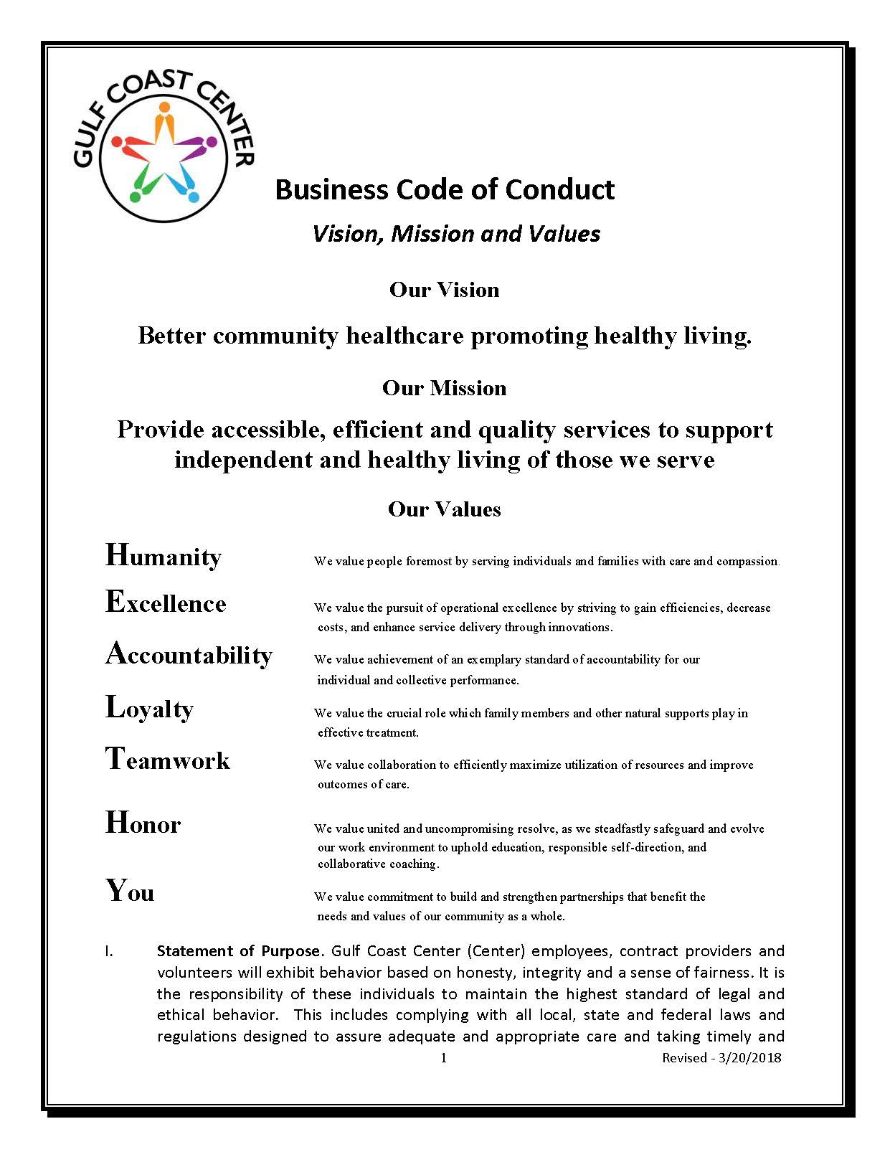
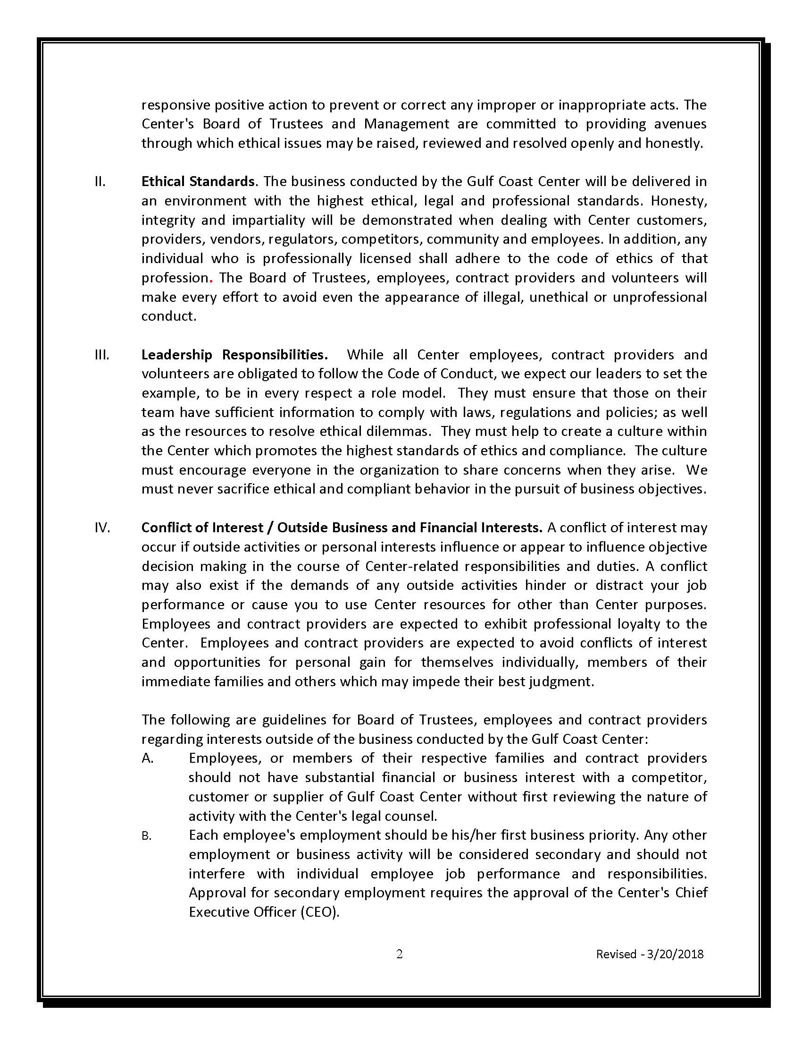
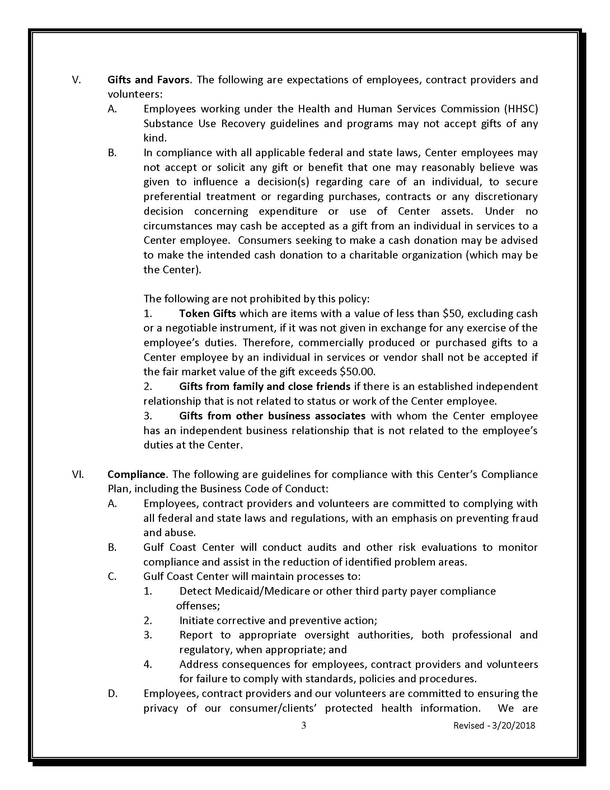
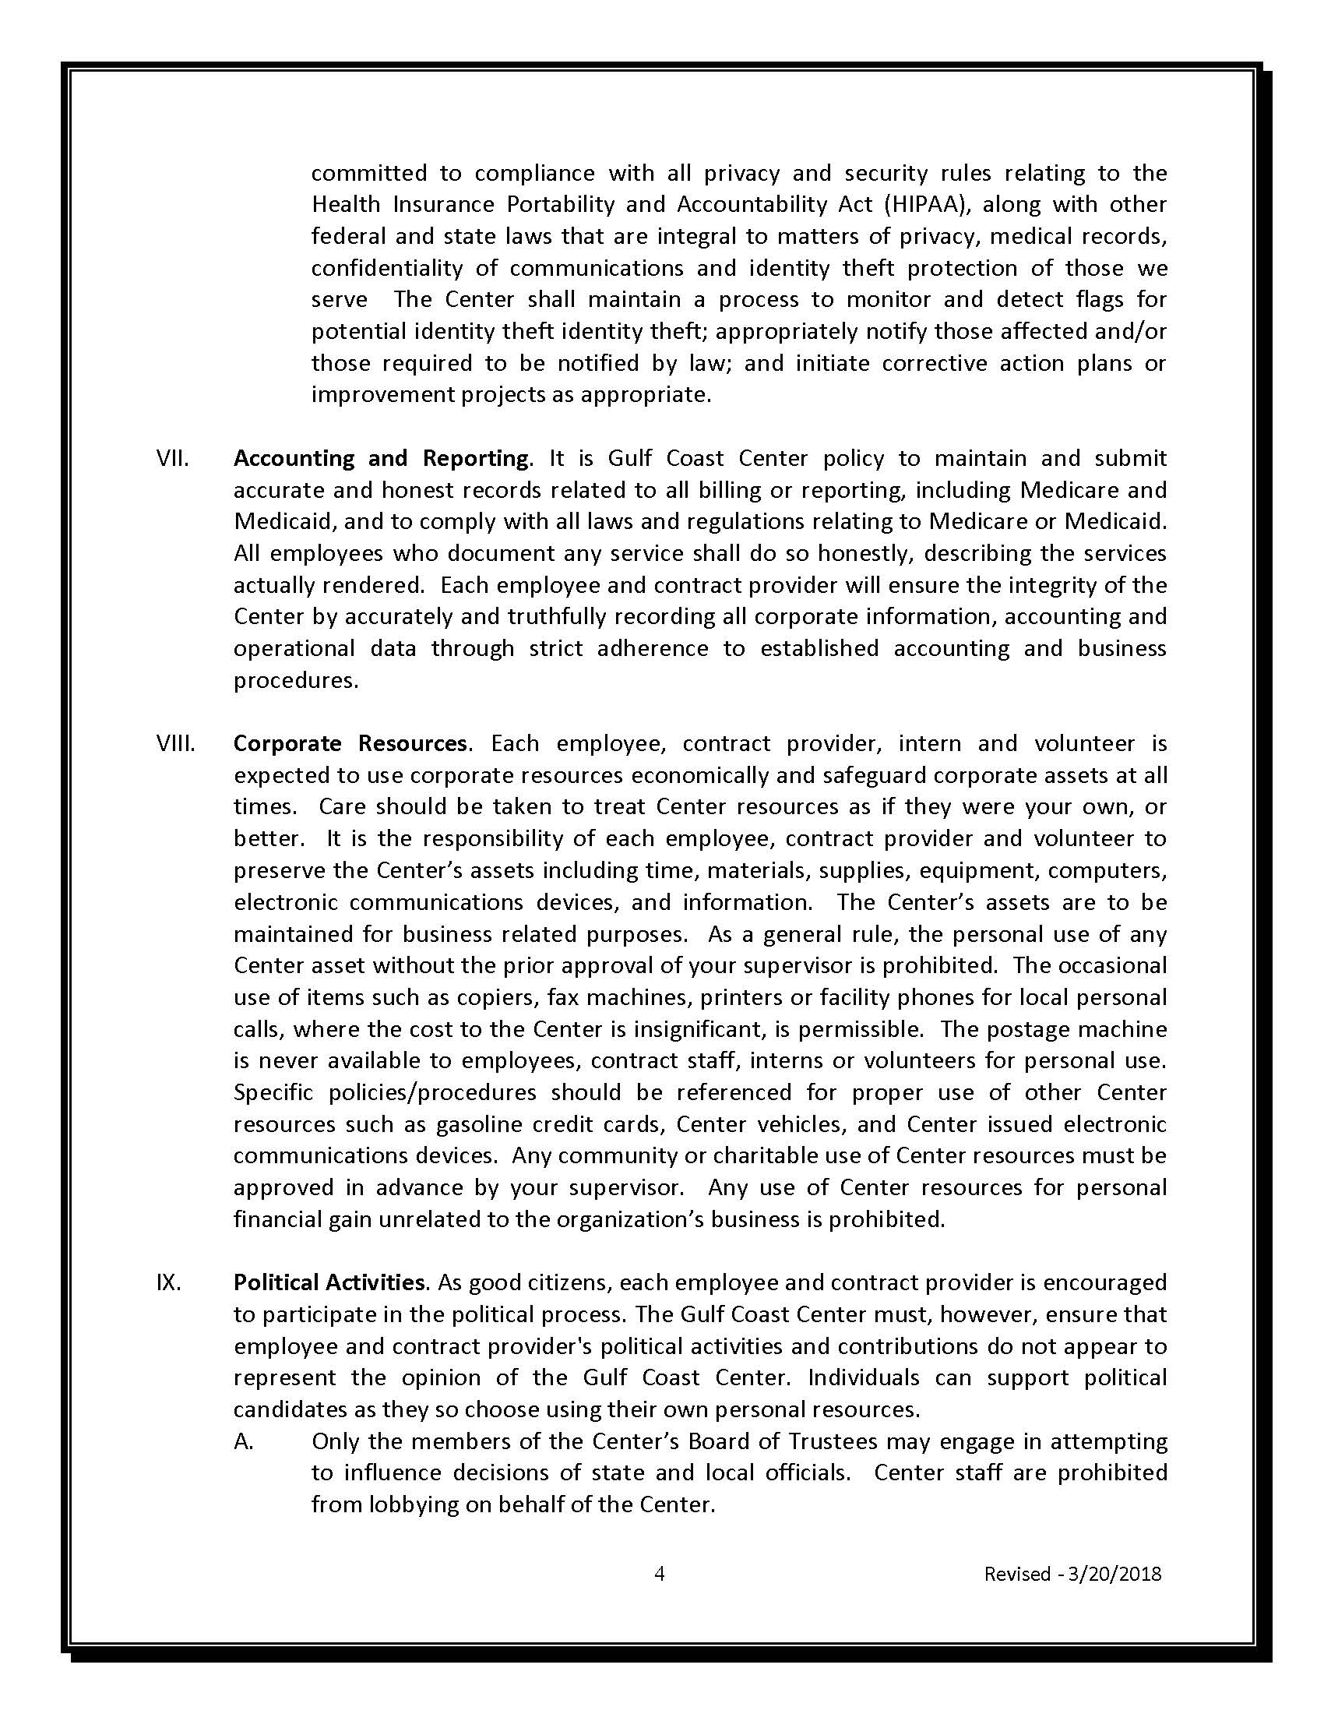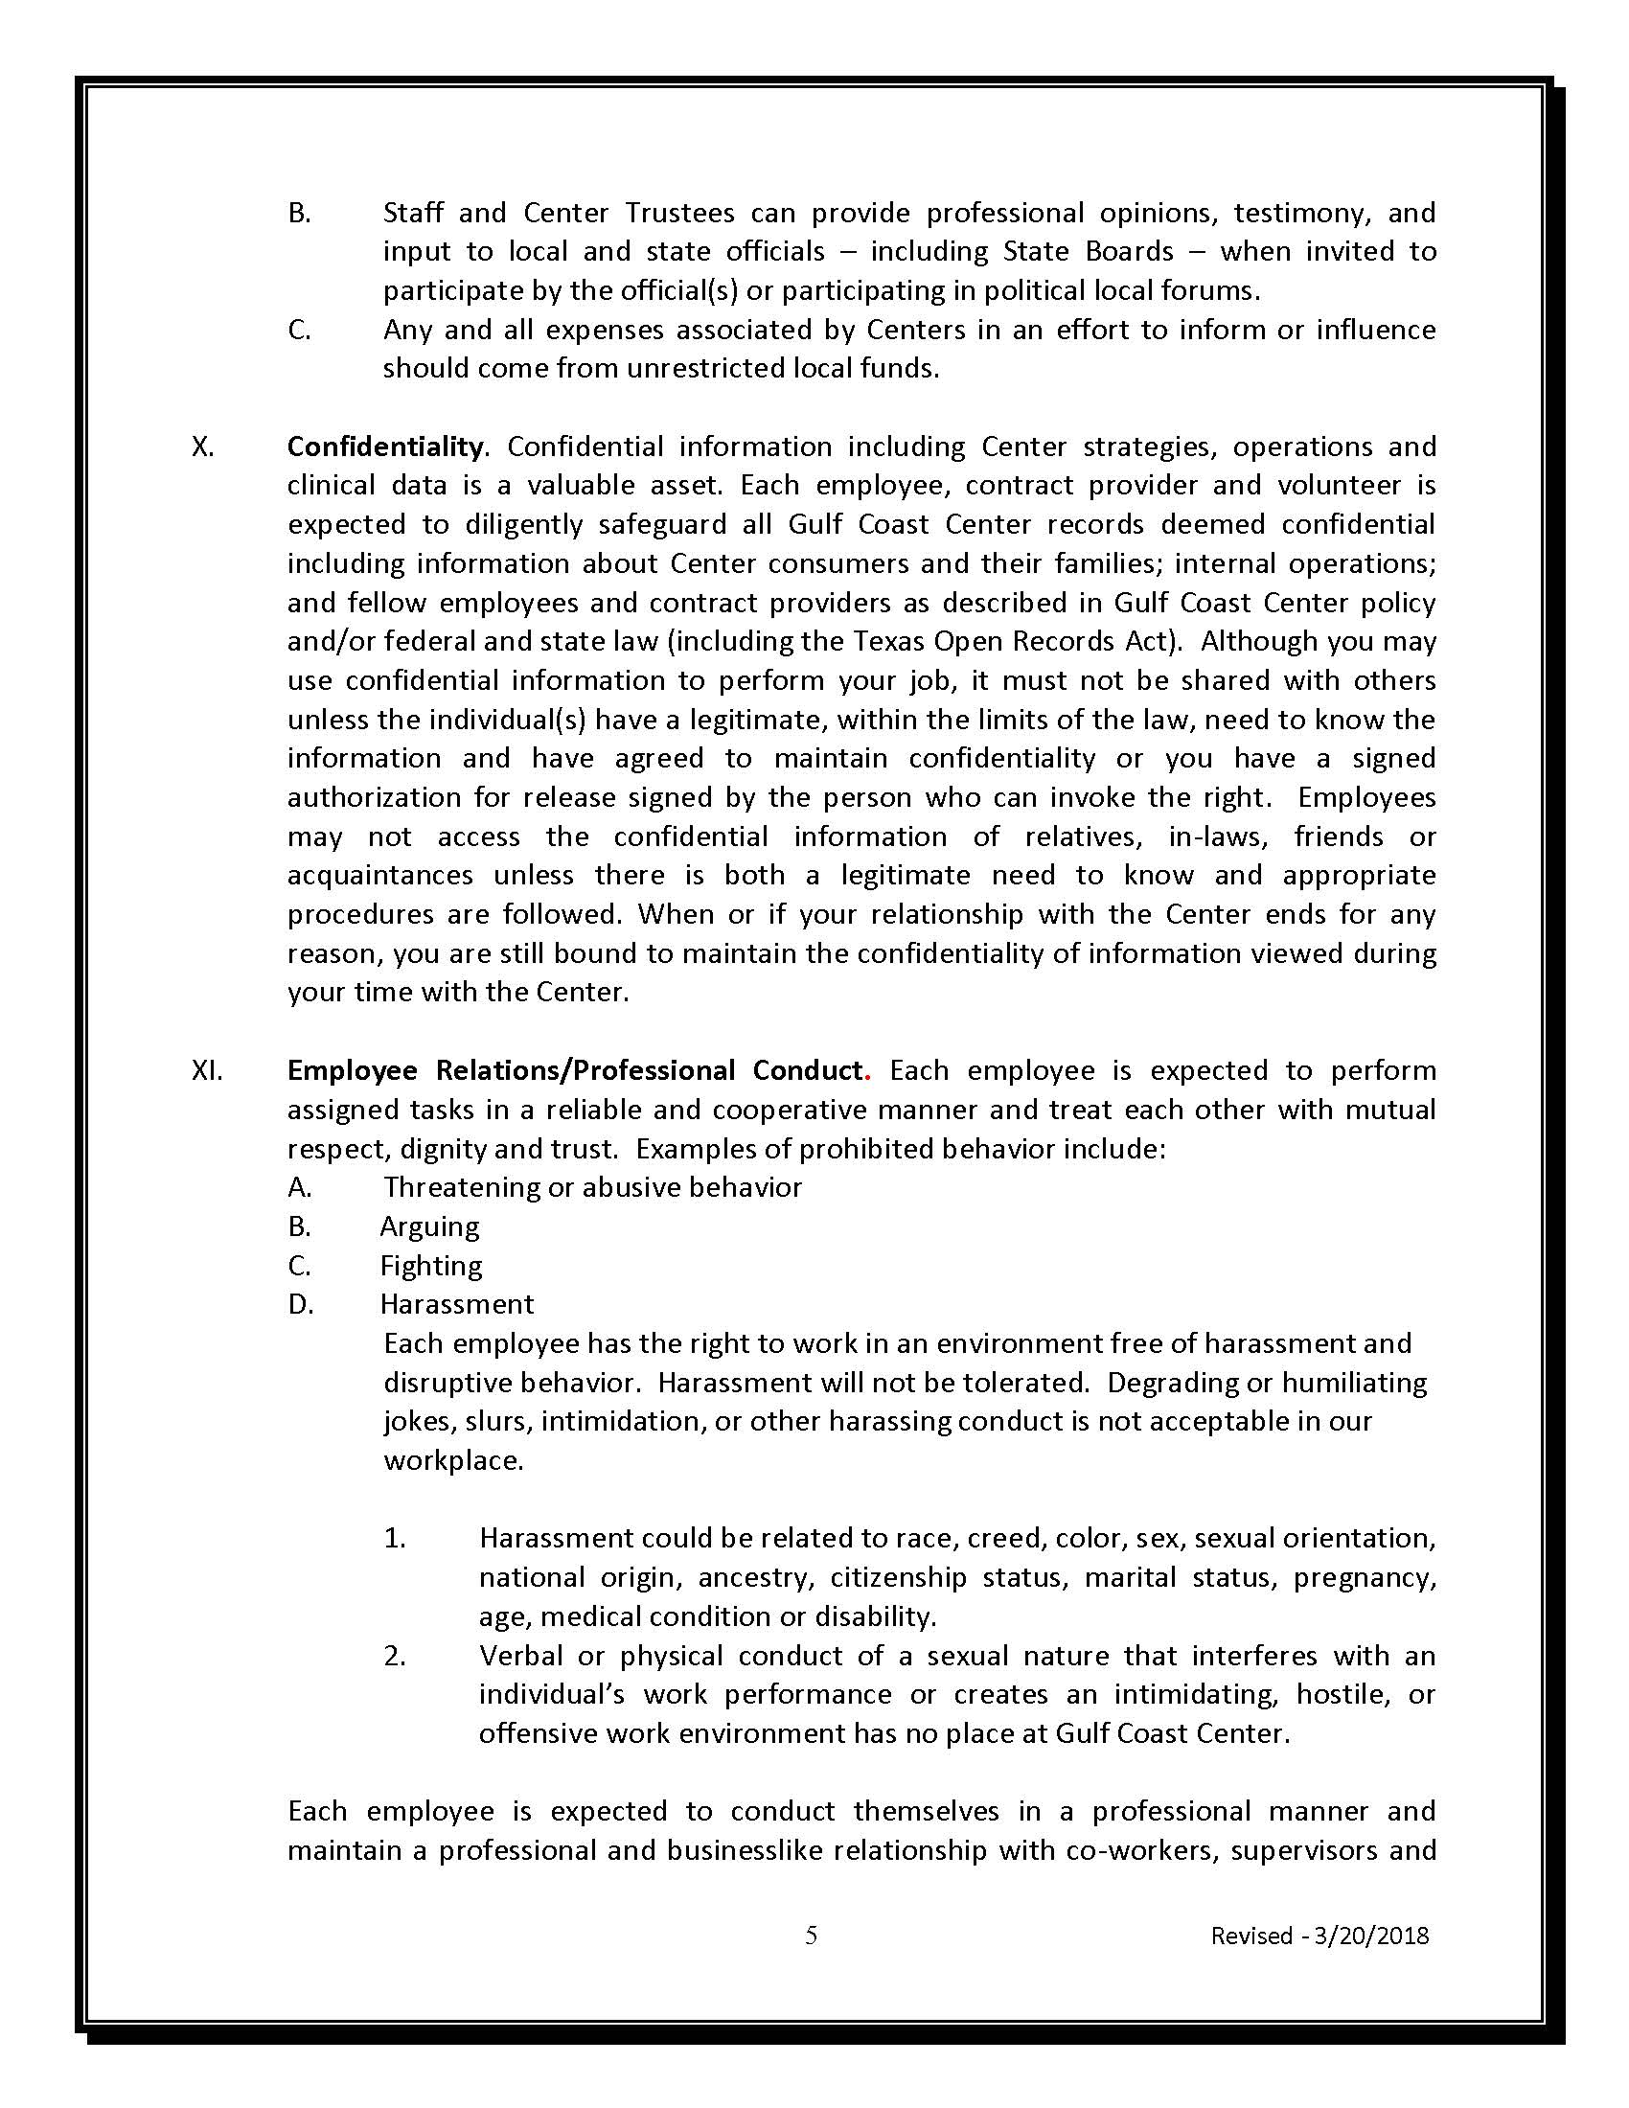
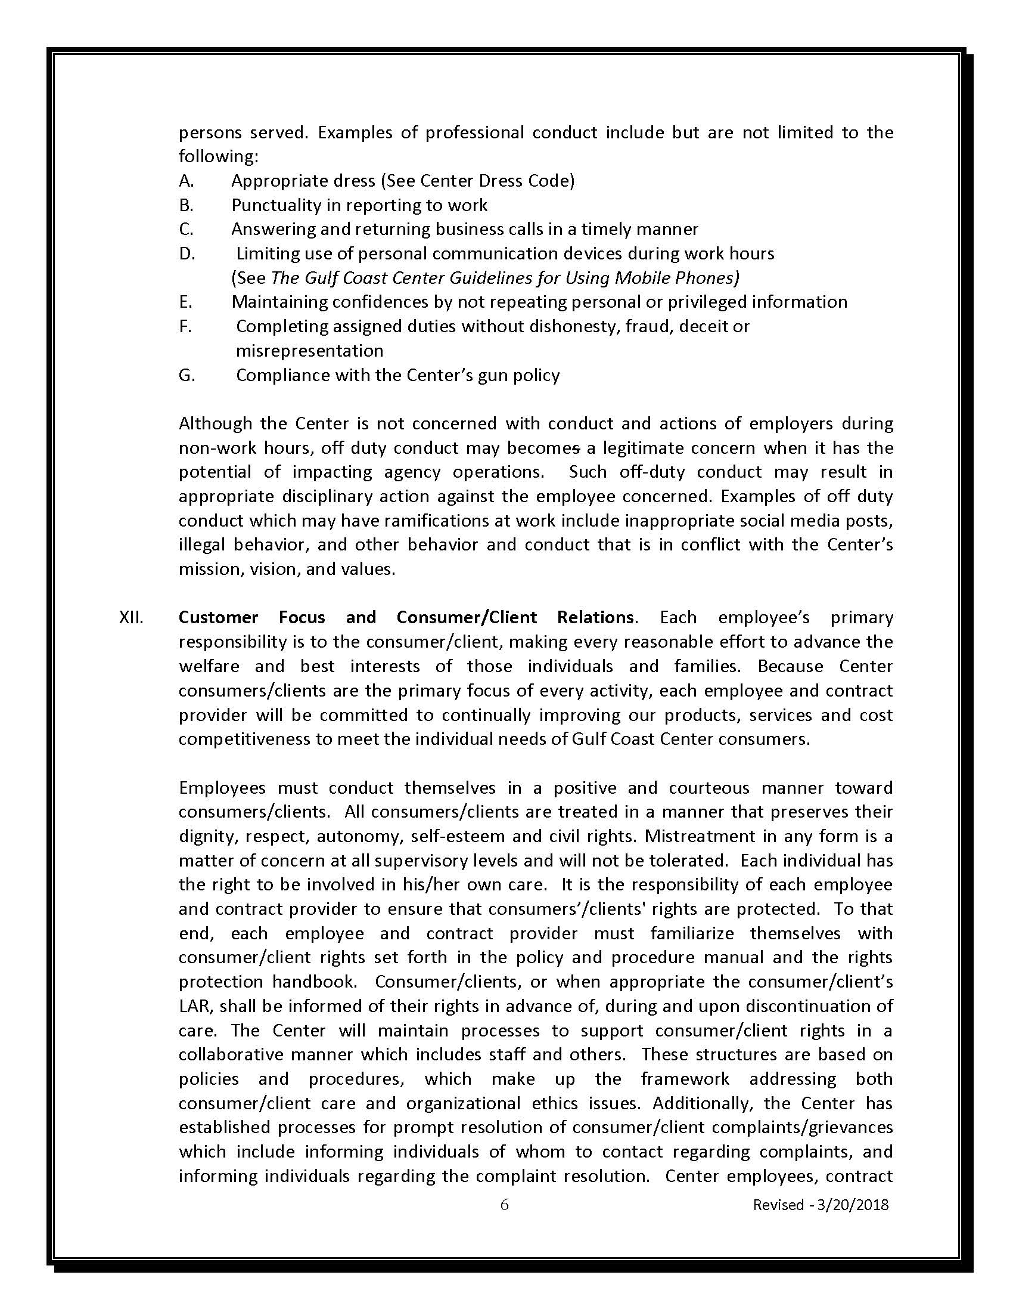
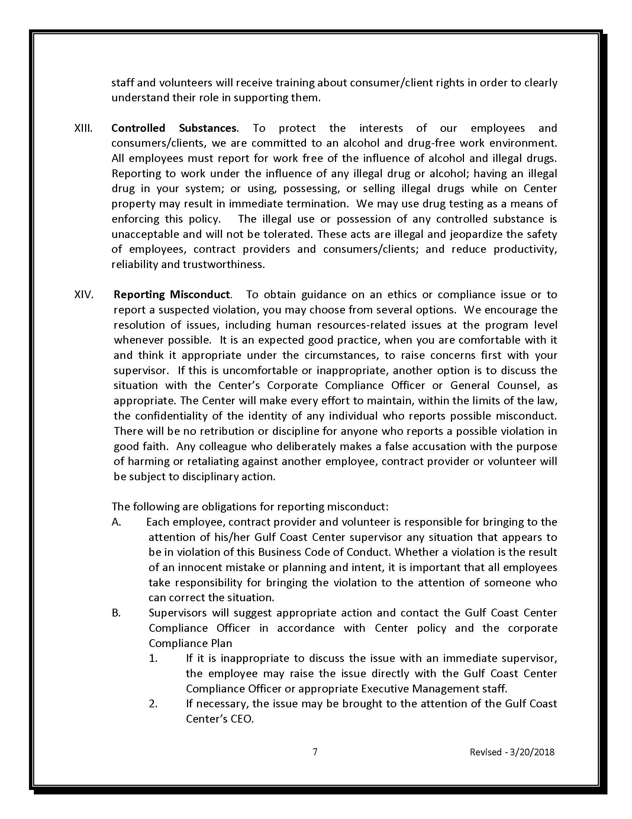
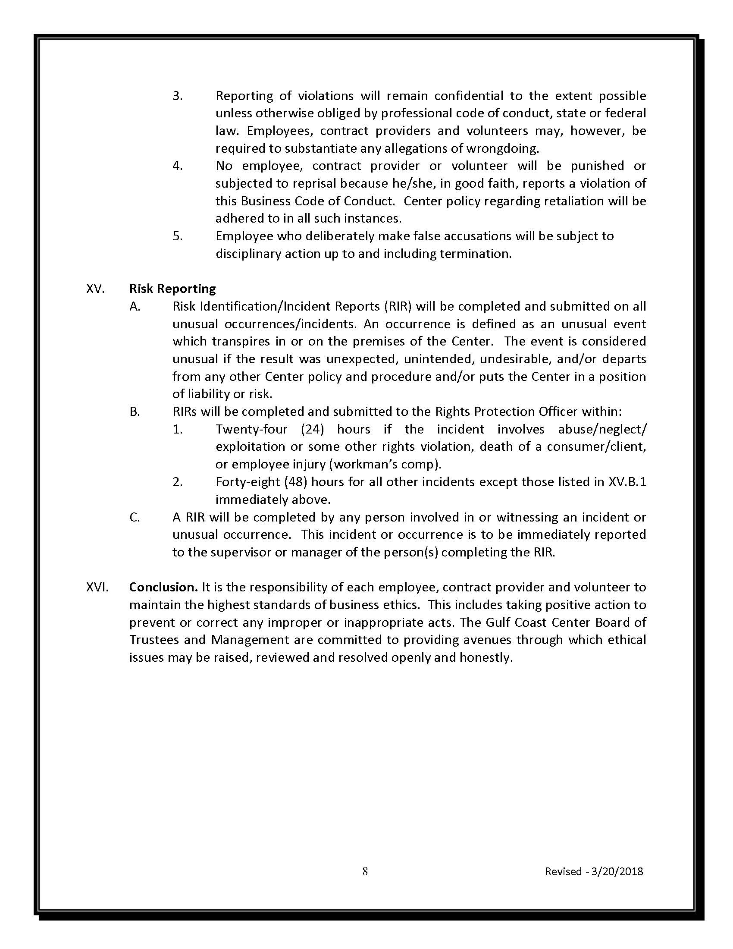

Exhibit C – Conflict of Interest Questionnaire
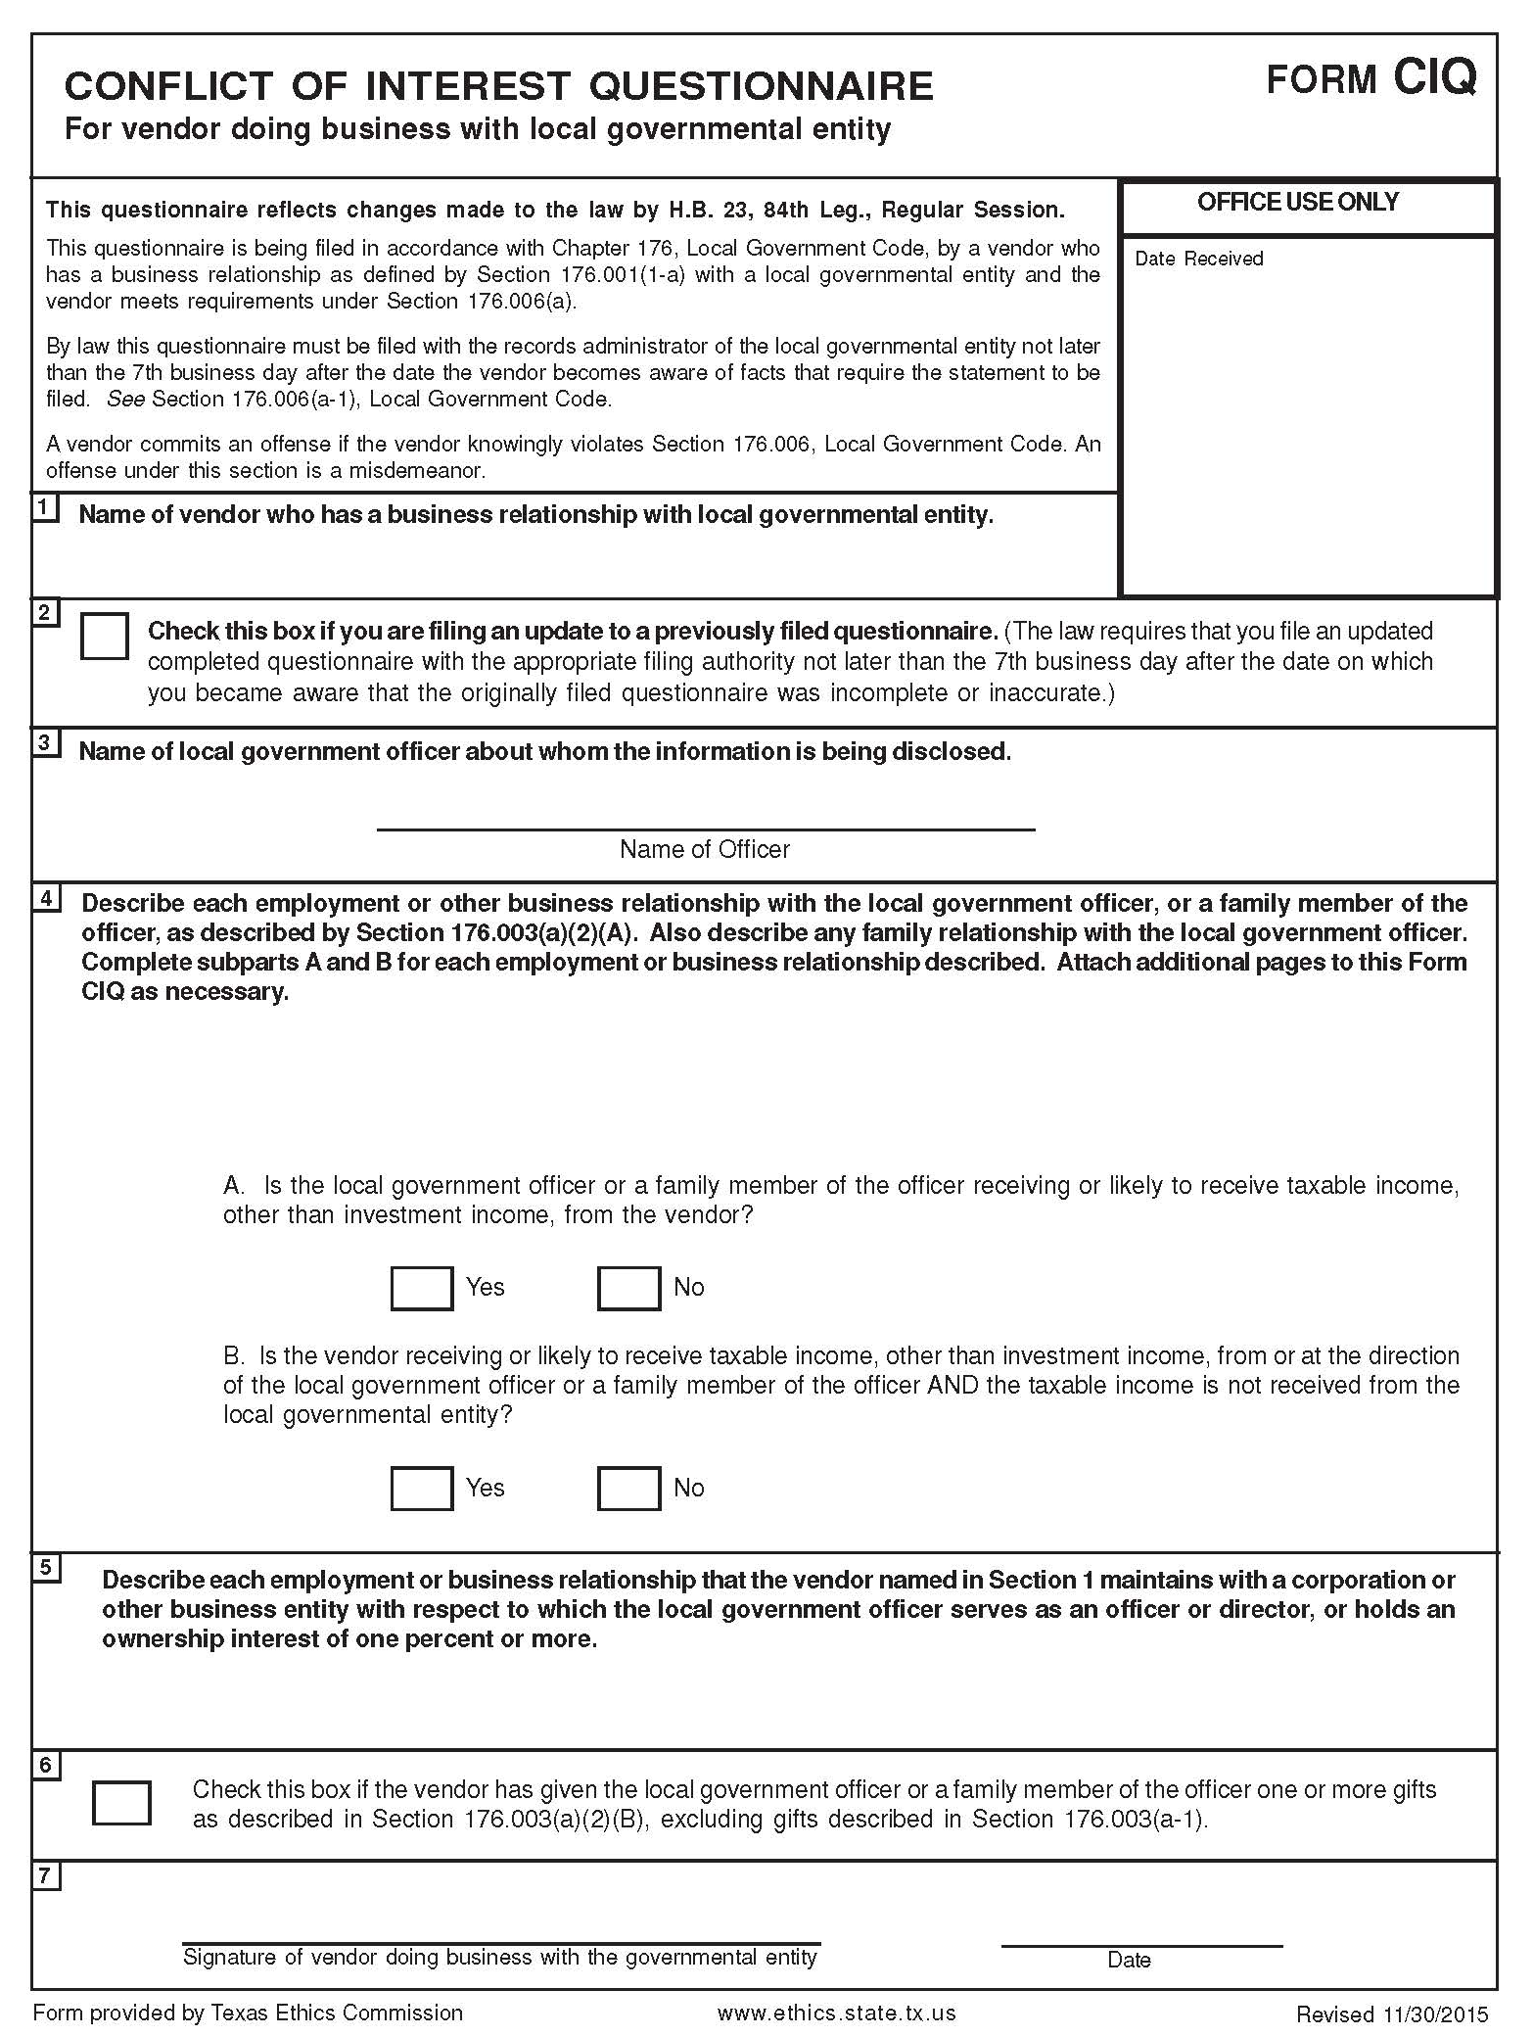
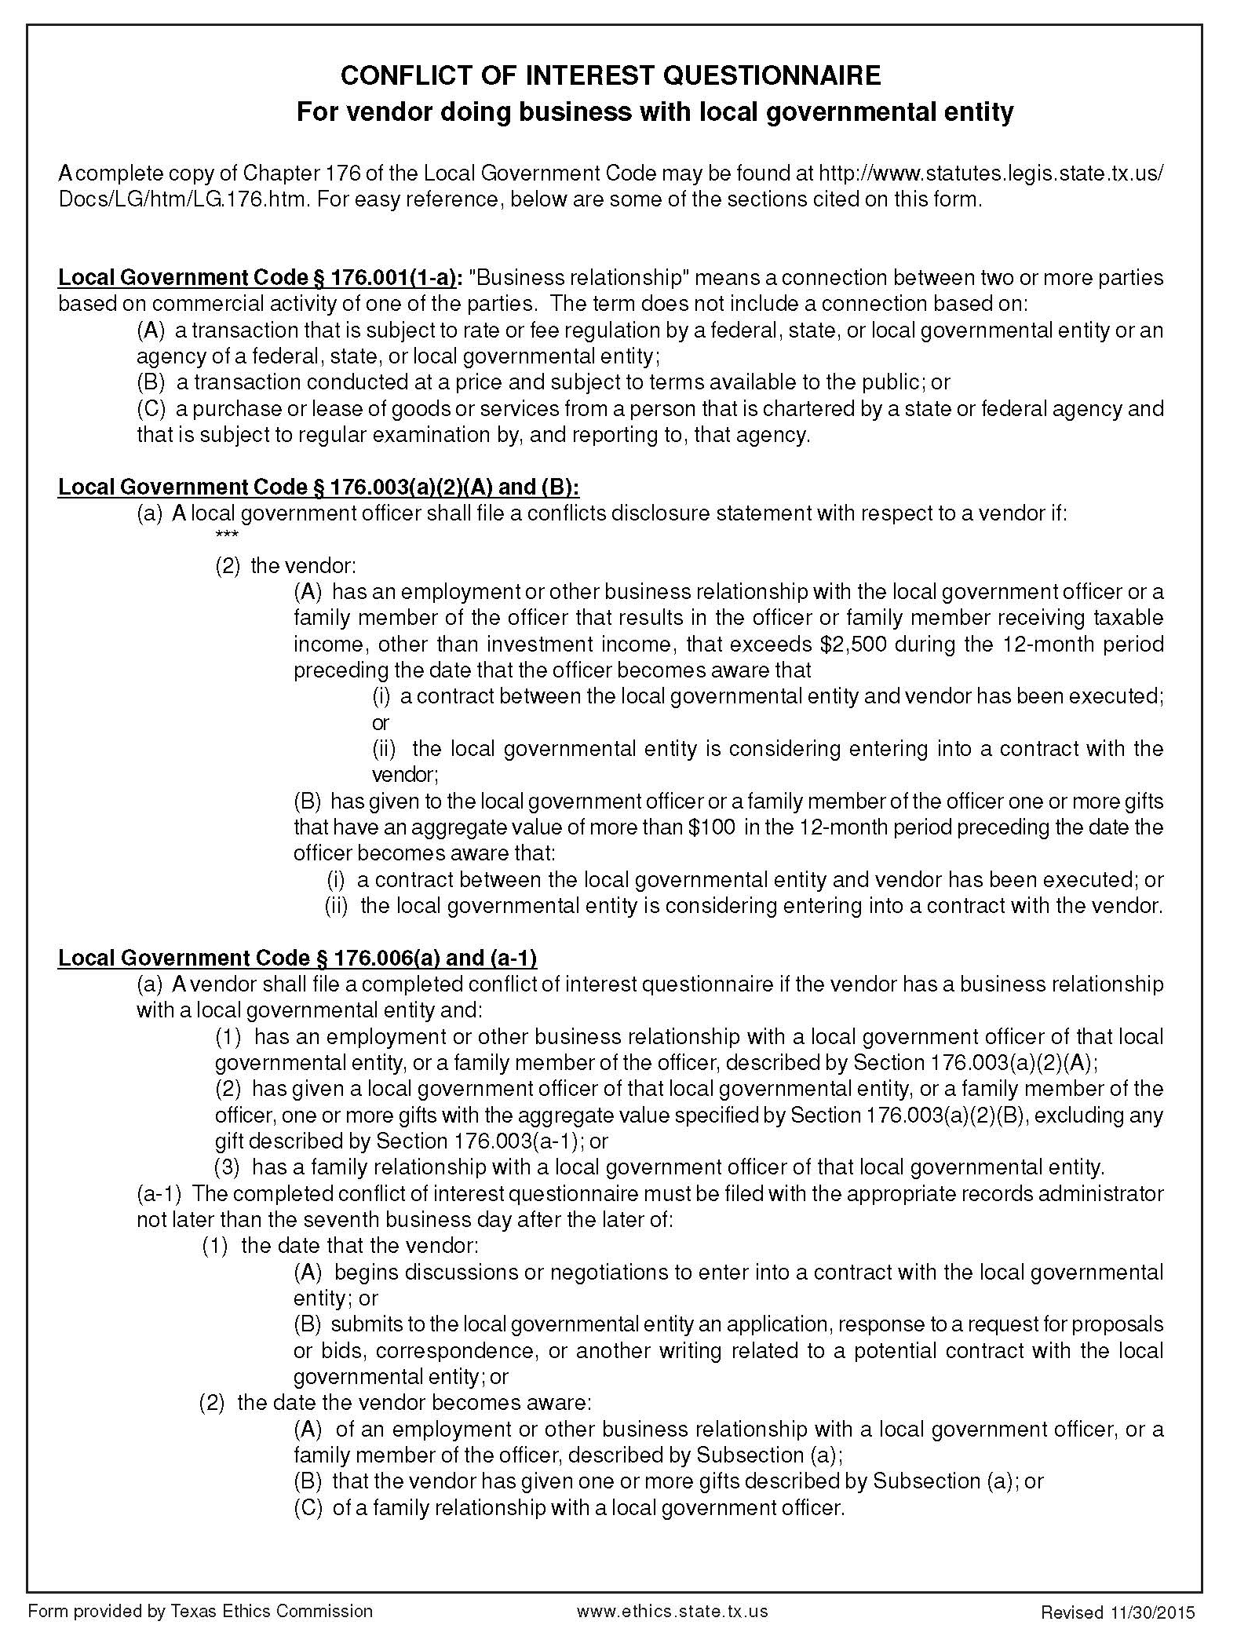

Exhibit D – Federally Required Contract Clauses
- FLY AMERICA
  - The Respondent/Contractor agrees to comply with 49 U.S.C. 40118 (the “Fly America” Act) in accordance with the General Services Administration’s regulations at 41 CFR Part 301-10, which provide that recipients and subrecipients of Federal funds and their Respondents/Contractors are required to use U.S. Flag air carriers for U.S Government-financed international air travel and transportation of their personal effects or property, to the extent such service is available, unless travel by foreign air carrier is a matter of necessity, as defined by the Fly America Act. The Respondent/Contractor shall submit, if a foreign air carrier was used, an appropriate certification or memorandum adequately explaining why service by a U.S. flag air carrier was not available or why it was necessary to use a foreign air carrier and shall, in any event, provide a certificate of compliance with the Fly America requirements.
  - The Respondent/Contractor also agrees to include any applicable requirements in each subcontract involving international air transportation financed in whole or in part with Federal assistance provided by FTA.
- BUY AMERICA – Does not apply to this contract.
- CHARTER BUS and SCHOOL BUS REQUIREMENTS
  - Charter Service Operations – Does not apply to this contract.
  - School Bus Operations – Does not apply to this contract.
- CARGO PREFERENCE REQUIREMENTS – Does not apply to this contract.
- SEISMIC SAFETY REQUIREMENTS – Does not apply to this contract.
- ENERGY CONSERVATION
  - As authorized by the State of Texas, The Texas State Energy Conservation Office (SECO) has adopted the most recent edition of the International Energy Conservation Code (IECC) without amendment for new buildings or additions only. The Respondent/Contractor shall design the facility in accordance with 2015 IECC.
  - The Respondent/Contractor also agrees to include any applicable requirements in each subcontract involving construction of commercial buildings financed in whole or in part with Federal assistance provided by FTA.
- CLEAN WATER
  - The Respondent/Contractor agrees to comply with all applicable standards, orders or regulations issued pursuant to the Federal Water Pollution Control Act, as amended, 33 U.S.C. 1251 et seq. The Respondent/Contractor agrees to report each violation to the Center and understands and agrees that the Center will, in turn, report each violation as required to assure notification to FTA and the appropriate EPA Regional Office.
  - The Respondent/Contractor also agrees to include these requirements in each subcontract exceeding $150,000 financed in whole or in part with Federal assistance provided by FTA.
- BUS TESTING – Does not apply to this contract.
- PRE-AWARD and POST DELIVERY AUDIT REQUIREMENTS – Does not apply to this contract.
- LOBBYING
  - Respondents/Contractors who apply for an award of $100,000 or more shall file the Certification Regarding Lobbying, required by 49 CFR Part 20, New Restrictions on Lobbying, with the Center. Each subcontractor shall file the Certification Regarding Lobbying with the Respondent/Contractor that it will not and has not used Federal appropriated funds to pay any person or organization for influencing or attempting to influence an officer or employee of any agency, a Member of Congress, officer or employee of Congress, or an employee of a Member of Congress in connection with obtaining any Federal contract, grant or any other award covered by 31 U.S.C. 1352.
  - The Respondent/Contractor and subcontractors shall also disclose any lobbying with non-Federal funds that takes place in connection with obtaining any Federal award. Such disclosures are forwarded from subcontractors to Respondent/Contractor to the Center.
  - The certification regarding lobbying (See EXHIBIT E) is to be completed by the Respondent/Contractor and subcontractor(s) is provided herein under Certifications and Forms Section.
- ACCESS TO RECORDS AND REPORTS
The following access to records requirements applies to this contract:
  - The Center is an FTA Recipient in accordance with 49 C.F.R. 18.36(i). The Respondent/Contractor agrees to provide the Center, the FTA Administrator, the Comptroller General of the United States or any of their authorized representatives access to any books, documents, papers and records of the Respondent/Contractor which are directly pertinent to this contract for the purposes of making audits, examinations, excerpts and transcriptions.
  - The Respondent/Contractor agrees to permit any of the foregoing parties to reproduce by any means whatsoever or to copy excerpts and transcriptions as reasonably needed.
  - The Respondent/Contractor agrees to maintain all books, records, accounts and reports required under this contract for a period of not less than three years after the date of termination or expiration of this contract, except in the event of litigation or settlement of claims arising from the performance of this contract, in which case Respondent/Contractor agrees to maintain same until the Center, the FTA Administrator, the Comptroller General, or any of their duly authorized representatives, have disposed of all such litigation, appeals, claims or exceptions related thereto. Reference 49 C.F.R. 18.39(i)(11).
  - FTA does not require the inclusion of these requirements in subcontracts.
- FEDERAL CHANGES
  - The Respondent/Contractor shall at all times comply with all applicable FTA regulations, policies, procedures and directives, including without limitation those listed directly or by reference in the Master Agreement between the Center and FTA, as they may be amended or promulgated from time to time during the term of this contract. The Respondent/Contractor’s failure to so comply shall constitute a material breach of this contract.
  - The Respondent/Contractor also agrees to include any applicable requirements in each subcontract involving a federal change financed in whole or in part with Federal assistance provided by FTA.
- BONDING REQUIREMENTS – Does not apply to this contract.
- CLEAN AIR
  - The Respondent/Contractor agrees to comply with all applicable standards, orders or regulations issued pursuant to the Clean Air Act, as amended, 42 U.S.C. §§ 7401 et seq. The Respondent/Contractor agrees to report each violation to the Center and understands and agrees that the Center will, in turn, report each violation as required to assure notification to FTA and the appropriate EPA Regional Office.
  - The Respondent/Contractor also agrees to include these requirements in each subcontract exceeding $150,000 financed in whole or in part with Federal assistance provided by FTA.
- RECYCLED PRODUCTS – Does not apply to this contract.
- DAVIS-BACON and COPELAND ANTI-KICKBACK ACTS – Does not apply to this contract.
- CONTRACT WORK HOURS and SAFETY STANDARDS ACT– Does not apply to this contract.
- RESERVED
- NO FEDERAL GOVERNMENT OBLIGATION TO THIRD PARTIES
  - The Center and the Respondent/Contractor acknowledge and agree that, notwithstanding any concurrence by the Federal Government in or approval of the solicitation or award of the underlying contract, absent the express written consent by the Federal Government, the Federal Government is not a party to this contract and shall not be subject to any obligations or liabilities to the Center, the Respondent/Contractor, or any other party (whether or not a party to that contract) pertaining to any matter resulting from the underlying contract.
  - The Respondent/Contractor agrees to include the above clause in each subcontract financed in whole or in part with Federal assistance provided by FTA. It is further agreed that the clause shall not be modified, except to identify the subcontractor who will be subject to its provisions.
- PROGRAM FRAUD and FALSE OR FRAUDULENT STATEMENTS AND RELATED ACTS
  - The Respondent/Contractor acknowledges that the provisions of the Program Fraud Civil Remedies Act of 1986, as amended, 31 U.S.C. § 3801 et seq. and U.S. DOT regulations, “Program Fraud Civil Remedies,” 49 C.F.R. Part 31, apply to its actions pertaining to this Project. Upon execution of the underlying contract, the Respondent/Contractor certifies or affirms the truthfulness and accuracy of any statement it has made, it makes, it may make, or causes to be made, pertaining to the underlying contract or the FTA assisted project for which this contract work is being performed. In addition to other penalties that may be applicable, the Respondent/Contractor further acknowledges that if it makes, or causes to be made, a false, fictitious, or fraudulent claim, statement, submission, or certification, the Federal Government reserves the right to impose the penalties of the Program Fraud Civil Remedies Act of 1986 on the Respondent/Contractor to the extent the Federal Government deems appropriate.
  - The Respondent/Contractor also acknowledges that if it makes, or causes to be made, a false, fictitious, or fraudulent claim, statement, submission, or certification to the Federal Government under a contract connected with a project that is financed in whole or in part with Federal assistance originally awarded by FTA under the authority of 49 U.S.C. § 5307, the Government reserves the right to impose the penalties of 18 U.S.C. § 1001 and 49 U.S.C. § 5307(n)(1) on the Respondent/Contractor, to the extent the Federal Government deems appropriate.
  - The Respondent/Contractor agrees to include the above two clauses in each subcontract financed in whole or in part with Federal assistance provided by FTA. It is further agreed that the clauses shall not be modified, except to identify the subcontractor who will be subject to the provisions.
- TERMINATION
The contract may be terminated under the following conditions:
  - Termination for Convenience. The Center may terminate this contract, in whole or in part, at any time by written notice to the Respondent/Contractor when it is in the Center’s best interest. The Respondent/Contractor shall be paid its costs, including contract close-out costs, and profit on work performed up to the time of termination. The Respondent/Contractor shall promptly submit its termination claim to the Center to be paid to the Respondent/Contractor. If the Respondent/Contractor has any property in its possession belonging to Connect Transit, the Respondent/Contractor will account for the same, and dispose of it in the manner Connect Transit directs.
  - Termination for Default [Breach or Cause]. If the Respondent/Contractor does not deliver supplies in accordance with the contract delivery schedule, or, if the contract is for services, the Respondent/Contractor fails to perform in the manner called for in the contract, or if the Respondent/Contractor fails to comply with any other provisions of the contract, the Center may terminate this contract for default. Termination shall be affected by serving a notice of termination on the Respondent/Contractor setting forth the manner in which the Respondent/Contractor is in default. The Respondent/Contractor will only be paid the contract price for supplies delivered and accepted, or services performed in accordance with the manner of performance set forth in the contract.
If it is later determined by the Center that the Respondent/Contractor had an excusable reason for not performing, such as a strike, fire, or flood, events which are not the fault of or are beyond the control of the Respondent/Contractor, the Center, after setting up a new delivery of performance schedule, may allow the Respondent/Contractor to continue work, or treat the termination as a termination for convenience.
  - Opportunity to Cure. The Center in its sole discretion may, in the case of a termination for breach or default, allow the Respondent/Contractor thirty (30) days in which to cure the defect. In such case, the notice of termination will state the time period in which cure is permitted and other appropriate conditions.
If Respondent/Contractor fails to remedy to the Center's satisfaction the breach or default of any of the terms, covenants, or conditions of this Contract within ten (10) days after receipt by Respondent/Contractor of written notice from the Center setting forth the nature of said breach or default, the Center shall have the right to terminate the Contract without any further obligation to Respondent/Contractor. Any such termination for default shall not in any way operate to preclude the Center from also pursuing all available remedies against Respondent/Contractor and its sureties for said breach or default.
  - Waiver of Remedies for any Breach. In the event that the Center elects to waive its remedies for any breach by the Respondent/Contractor of any covenant, term or condition of this Contract, such waiver by the Center shall not limit the Center’s remedies for any succeeding breach of that or of any other term, covenant, or condition of this Contract.
  - Termination for Convenience. The Center, by written notice, may terminate this contract, in whole or in part, when it is in the Government's interest. If this contract is terminated, the Center shall be liable only for payment under the payment provisions of this contract for services rendered before the effective date of termination.
  - The Respondent/Contractor also agrees to include these requirements in each subcontract exceeding $10,000 financed in whole or in part with Federal assistance provided by FTA.
- GOVERNMENT-WIDE DEBARMENT AND SUSPENSION
  - This contract is a covered transaction for purposes of 49 C.F.R. Part 29. As such, the Respondent/Contractor is required to verify that none of the Respondent/Contractor, its principals, as defined at 49 C.F.R. 29.995, or affiliates, as defined at 49 C.F.R. 29.905, are excluded or disqualified as defined at 49 C.F.R. 29.940 and 29.945.
  - The Respondent/Contractor is required to comply with 49 C.F.R. 29, Subpart C and must include the requirement to comply with 49 C.F.R. 29, Subpart C in any lower tier covered transaction it enters into.
  - The certification (See EXHIBIT E) is a material representation of fact relied upon by the Center. If it is later determined that the Respondent/Contractor knowingly rendered an erroneous certification, in addition to remedies available to the Center, the Federal Government may pursue available remedies, including but not limited to suspension and/or debarment. The Respondent/Contractor agrees to comply with the requirements of 49 C.F.R. 29, Subpart C and Executive Order 12549 while this offer is valid and throughout the period of any contract that may arise from this offer.
  - The Respondent/Contractor also agrees to include these requirements in each subcontract exceeding $25,000 financed in whole or in part with Federal assistance provided by FTA.
- PRIVACY ACT – Does not apply to this contract.
- CIVIL RIGHTS REQUIREMENTS
The following requirements apply to the underlying contract:
  - Nondiscrimination - In accordance with Title VI of the Civil Rights Act, as amended, 42 U.S.C. § 2000d, section 303 of the Age Discrimination Act of 1975, as amended, 42 U.S.C. § 6102, section 202 of the Americans with Disabilities Act of 1990, 42 U.S.C. § 12132, and Federal transit law at 49 U.S.C. § 5332, the Respondent/Contractor agrees that it will not discriminate against any employee or applicant for employment because of race, color, creed, national origin, sex, age, or disability. In addition, the Respondent/Contractor agrees to comply with applicable Federal implementing regulations and other implementing requirements FTA may issue.
  - Equal Employment Opportunity - The following requirements apply to the underlying contract:
    - Race, Color, Creed, National Origin, Sex - In accordance with Title VII of the Civil Rights Act, as amended, 42 U.S.C. § 2000e, and Federal transit laws at 49 U.S.C. § 5332, the Respondent/Contractor agrees to comply with all applicable equal employment opportunity requirements of U.S. Department of Labor (U.S. DOL) regulations, “Office of Federal Contract Compliance Programs, Equal Employment Opportunity, Department of Labor,” 41 C.F.R. Parts 60 et seq., (which implement Executive Order No. 11246, “Equal Employment Opportunity,” as amended by Executive Order No. 11375, “Amending Executive Order 11246 Relating to Equal Employment Opportunity,” 42 U.S.C. § 2000e note), and with any applicable Federal statutes, executive orders, regulations, and Federal policies that may in the future affect construction activities undertaken in the course of the Project. The Respondent/Contractor agrees to take affirmative action to ensure that applicants are employed, and that employees are treated during employment, without regard to their race, color, creed, national origin, sex, or age. Such action shall include, but not be limited to, the following: employment, upgrading, demotion or transfer, recruitment or recruitment advertising, layoff or termination; rates of pay or other forms of compensation; and selection for training, including apprenticeship. In addition, the Respondent/Contractor agrees to comply with any implementing requirements FTA may issue.
    - Age - In accordance with section 4 of the Age Discrimination in Employment Act of 1967, as amended, 29 U.S.C. § 623 and Federal transit law at 49 U.S.C. § 5332, the Respondent/Contractor agrees to refrain from discrimination against present and prospective employees for reason of age. In addition, the Respondent/Contractor agrees to comply with any implementing requirements FTA may issue.
    - Disabilities - In accordance with section 102 of the Americans with Disabilities Act, as amended, 42 U.S.C. § 12112, the Respondent/Contractor agrees that it will comply with the requirements of U.S. Equal Employment Opportunity Commission, “Regulations to Implement the Equal Employment Provisions of the Americans with Disabilities Act,” 29 C.F.R. Part 1630, pertaining to employment of persons with disabilities. In addition, the Respondent/Contractor agrees to comply with any implementing requirements FTA may issue.
  - The Respondent/Contractor also agrees to include these requirements in each subcontract financed in whole or in part with Federal assistance provided by FTA, modified only if necessary, to identify the affected parties.
- BREACHES AND DISPUTE RESOLUTION
The Center’s breach and dispute resolution requirements are as follows:
  - Disputes - Disputes arising in the performance of this Contract which are not resolved by agreement of the parties shall be decided in writing by the authorized representative of the Center's Transportation Director. This decision shall be final and conclusive unless within ten (10) days from the date of receipt of its copy, the Respondent/Contractor mails or otherwise furnishes a written appeal to the Chief Financial Officer. In connection with any such appeal, the Respondent/Contractor shall be afforded an opportunity to be heard and to offer evidence in support of its position. The decision of the Center shall be binding upon the Respondent/Contractor and the Respondent/Contractor shall abide be the decision.
  - Performance During Dispute - Unless otherwise directed by the Center, Respondent/Contractor shall continue performance under this Contract while matters in dispute are being resolved.
  - Claims for Damages - Should either party to the Contract suffer injury or damage to person or property because of any act or omission of the party or of any of his employees, agents or others for whose acts he is legally liable, a claim for damages therefor shall be made in writing to such other party within a reasonable time after the first observance of such injury of damage.
  - Remedies - Unless this contract provides otherwise, all claims, counterclaims, disputes and other matters in question between the Center and the Respondent/Contractor arising out of or relating to this agreement or its breach will be decided by arbitration if the parties mutually agree, or in a court of competent jurisdiction within the State in which the Center is located.
  - Rights and Remedies - The duties and obligations imposed by the Contract Documents and the rights and remedies available thereunder shall be in addition to and not a limitation of any duties, obligations, rights and remedies otherwise imposed or available by law. No action or failure to act by the Center or the Respondent/Contractor shall constitute a waiver of any right or duty afforded any of them under the Contract, nor shall any such action or failure to act constitute an approval of or acquiescence in any breach thereunder, except as may be specifically agreed in writing.
  - The Respondent/Contractor also agrees to include any applicable requirements in each subcontract financed in whole or in part with Federal assistance provided by FTA.
- PATENT AND DISPUTE RESOLUTION – Does not apply to this contract.
- TRANSIT EMPLOYEE PROTECTIVE AGREEMENTS – Does not apply to this contract.
- DISADVANTAGED BUSINESS ENTERPRISES
  - Objective/Policy Statement - The Gulf Coast Center/Connect Transit has established a Disadvantaged Business Enterprise (DBE) program in accordance with regulations of the U.S. Department of Transportation (DOT), 49 CFR Part 26. The Center has received Federal financial assistance from the Department of Transportation, and as a condition of receiving this assistance, the Center has signed an assurance that it will comply with 49 CFR Part 26. The agency’s overall goal for DBE participation is 3.93%. A separate contract goal has not been established for this procurement.
  - Respondent/Contractor shall not discriminate on the basis of race, color, national origin, or sex in the performance of this contract. Respondent/Contractor shall carry out applicable requirements of 49 CFR Part 26 in the award and administration of this DOT-assisted contract. Failure by Respondent/Contractor to carry out these requirements is a material breach of this contract, which may result in the termination of this contract or such other remedy as the Center deems appropriate. Each subcontract Respondent/Contractor signs with a subcontractor must include the assurance in this paragraph (see 49 CFR 26.13(b)).
  - Respondent/Contractor is required to document all subcontractor participation including non-DBE subcontractors. Award of this contract is conditioned on submission of the following information in EXHIBIT E with the sealed bid:
    - The names and addresses of subcontractors that will participate in the contract;
    - A description of the work that each subcontractor will perform;
    - Whether the subcontractor is a DBE, non-DBE, or a Small Business Enterprise (SBE);
    - The ethnic code, as described in the form;
    - The gender code, as described in the form;
    - The age of the firm;
    - The annual gross receipts from the firm;
    - The dollar amount of the participation of each DBE firm participating; and
    - Written confirmation from the DBE subcontractor that it is participating in the contract as provided in the commitment made in the Respondent/Contractor Certification Form (EXHIBIT E).
  - The Respondent/Contractor shall not discriminate on the basis of race, color, national origin, or sex in the performance of this contract. The Respondent/Contractor shall carry out applicable requirements of 49 C.F.R. Part 26 in the award and administration of DOT-assisted contracts. Failure by the Respondent/Contractor to carry out these requirements is a material breach of this contract, which may result in the termination of this contract or such other remedy as the Center deems appropriate. Each subcontract the Respondent/Contractor signs with a subcontractor must include the assurance in this paragraph.
  - The Respondent/Contractor agrees to pay each subcontractor under this prime contract for satisfactory performance of its contract no later than ten (10) days from the receipt of each payment the prime contractor receives from the Center. The Respondent/Contractor agrees further to return retainage payments to each subcontractor within thirty (30) days after the subcontractor’s work is satisfactorily completed. Any delay or postponement of payment from the timeframe stated in this paragraph may occur only for good cause, as determined by the Center, and following written approval of the Center. This clause applies to both DBE and non-DBE subcontractors and shall be included in the contract between the Respondent/Contractor and any and all subcontractors.
  - The Respondent/Contractor must promptly notify the Center, whenever a DBE subcontractor performing work related to this contract is terminated or fails to complete its work and must make good faith efforts to engage another DBE subcontractor to perform at least the same amount of work. The Respondent/Contractor may not terminate any DBE subcontractor and perform that work through its own forces or those of an affiliate without prior written consent of the Center.
  - The Respondent/Contractor shall report DBE participation on a monthly basis on the Contractor Payment Report Form (EXHIBIT E).
  - For the Respondent/Contractor’s convenience, a listing of potential DBE subcontractors listed in the Texas Unified Certification Program DBE Directory (https://txdot.txdotcms.com/Default.asp).
  - The Center encourages the Respondent/Contractor on DOT-assisted contract to make use of financial institution owned and controlled by socially and economically disadvantaged individuals. The Federal Reserve Statistical Release maintains a list of Minority-Owned Banks (http://www.federalreserve.gov/releases/mob/).
- RESERVED
- INCORPORATION OF FEDERAL TRANSIT ADMINISTRATION (FTA) TERMS
  - The preceding provisions include, in part, certain Standard Terms and Conditions required by DOT, whether or not expressly set forth in the preceding contract provisions. All contractual provisions required by DOT, as set forth in FTA Circular 4220.1F are hereby incorporated by reference. Anything to the contrary herein notwithstanding, all FTA mandated terms shall be deemed to control in the event of a conflict with other provisions contained in this Agreement. The Respondent/Contractor shall not perform any act, fail to perform any act, or refuse to comply with any Center or Connect Transit requests that would be in violation of the FTA terms and conditions.
  - The Respondent/Contractor also agrees to include any applicable requirements in each subcontract financed in whole or in part with Federal assistance provided by FTA.
- DRUG AND ALCOHOL TESTING – Does not apply to this contract.
- ACCESSIBILITY
  - ADA Accessibility ensures that all individuals regardless of disability are not excluded from the participation in, be denied the benefits of, or be subjected to discrimination under any program or activity receiving Federal financial assistance.
  - The Respondent/Contractor agrees to comply with 49 U.S.C. § 5301(d), which states the Federal policy that elderly individuals and individuals with disabilities have the same right as other individuals to use public transportation services and facilities, and that special efforts shall be made in planning and designing those services and facilities to implement transportation accessibility rights for elderly individuals and individuals with disabilities.
  - The Respondent/Contractor also agrees to comply with all applicable provisions of section 504 of the Rehabilitation Act of 1973, as amended, with 29 U.S.C. § 794, which prohibits discrimination on the basis of disability; with the Americans with Disabilities Act of 1990 (ADA), as amended, 42 U.S.C. §§ 12101 et seq., which requires that accessible facilities and services be made available to individuals with disabilities; and with the Architectural Barriers Act of 1968, as amended, 42 U.S.C. §§4151 et seq., which requires that buildings and public accommodations be accessible to individuals with disabilities; and with other laws and amendments thereto pertaining to access for individuals with disabilities that may be applicable.
  - In addition, the Respondent/Contractor agrees to comply with applicable implementing Federal regulations any later amendments thereto, and agrees to follow applicable Federal directives except to the extent FTA approves otherwise in writing
  - The Respondent/Contractor and all subcontractors shall adhere to any applicable ADA Accessibility requirements from the following:
    - 49 CFR Part 27 – Nondiscrimination on the Basis of Disability in Programs or Activities Receiving Federal Financial Assistance, U.S. DOT regulation
    - 49 CFR Part 37 - Transportation Services for Individuals with Disabilities (ADA), U.S. DOT regulation
    - 49 CFR Part 38 and 36 C.F.R. Part 1192 – Americans with Disabilities Act (ADA) Accessibility Specifications for Transportation Vehicles, Joint U.S. Architectural and Transportation Barriers Compliance Board (U.S. ATBCB)/U.S. DOT regulation
    - 28 C.F.R. Part 35 – Nondiscrimination on the Basis of Disability in State and Local Government Services, U.S. DOJ regulation
    - 28 C.F.R. Part 36 – Nondiscrimination on the Basis of Disability by Public Accommodations and in Commercial Facilities, U.S. DOJ regulation
    - 41 C.F.R. Subpart 101-19 – Accommodations for the Physically Handicapped, U.S. General Services Administration (U.S. GSA) regulation"
    - 29 C.F.R. Part 1630 – Regulations to Implement the Equal Employment Provisions of the Americans with Disabilities Act, U.S. EEOC
    - 47 C.F.R. Part 64, Subpart F – Telecommunications Relay Services and Related Customer Premises Equipment for the Hearing and Speech Disabled, U.S. Federal Communications Commission regulation
    - 36 C.F.R. Part 1194 – Electronic and Information Technology Accessibility Standards, U.S. ATBCB regulation
    - 49 C.F.R. Part 609 – Transportation for Elderly and Handicapped Persons, FTA regulation
    - Federal civil rights and nondiscrimination directives implementing the foregoing Federal laws and regulations, except to the extent the Federal Government determines otherwise in writing.
- Veteran’s Preference – Does not apply to this contract.
- Conformance with National ITS Architecture – Please see guidance at the following link: https://ops.fhwa.dot.gov/its_arch_imp/policy_2.htm

Exhibit E – Respondent Pre-Award Certifications

Respondent Initials:
1. Lobbying Certification _____
2. Suspension and Debarment Certification _____
3. Respondent/Contractor Certification _____
4. DBE Subcontractor Certification _____
5. Delinquent State Business Tax Certification _____
6. Certificate of Interested Parties N/A
7. Senate Bill 252 Certification N/A
8. House Bill 89 Verification _____
9. Contractor Payment Report Form N/A

I HEREBY ATTEST THAT EXHIBIT D, FEDERALLY REQUIRED CONTRACT CLAUSES, AND EXHIBIT E, RESPONDENT PRE-AWARD CERTIFICATIONS, WERE READ AND MY INITIALS ABOVE INDICATE THAT EACH ITEM WAS PROPERLY PREPARED AND EXECUTED.

DATE:
RESPONDENT:
SIGNATURE:
PRINT NAME:
TITLE:

Lobbying Certification Form
Certification for Contracts, Grants, Loans, and Cooperative Agreements (to be submitted with each bid or offer exceeding $100,000)
The Respondent/Contractor certifies that to the best of his or her knowledge and belief, that:
- No Federal appropriated funds have been paid or will be paid, by or on behalf of the undersigned, to any person for influencing or attempting to influence an officer or employee of an agency, a Member of Congress, an officer or employee of Congress, or an employee of a Member of Congress in connection with the awarding of any Federal contract, the making of any Federal grant, the making of any Federal loan, the entering into of any cooperative agreement, and the extension, continuation, renewal, amendment, or modification of any Federal contract, grant, loan, or cooperative agreement.
- If any funds other than Federal appropriated funds have been paid or will be paid to any person for making lobbying contacts to an officer or employee of any agency, a Member of Congress, an officer or employee of Congress, or an employee of a Member of Congress in connection with this Federal contract, grant, loan, or cooperative agreement, the undersigned shall complete and submit Standard Form--LLL, "Disclosure Form to Report Lobbying," in accordance with its instructions [as amended by "Government-wide Guidance for New Restrictions on Lobbying," 61 Fed. Reg. 1413 (1/19/96). Note: Language in paragraph (2) herein has been modified in accordance with Section 10 of the Lobbying Disclosure Act of 1995 (P.L. 104-65, to be codified at 2 U.S.C. 1601, et seq.)]
- The undersigned shall require that the language of this certification be included in the award documents for all sub-awards at all tiers (including subcontracts, sub-grants, and contracts under grants, loans, and cooperative agreements) and that all sub-recipients shall certify and disclose accordingly.

This certification is a material representation of fact upon which reliance was placed when this transaction was made or entered into. Submission of this certification is a prerequisite for making or entering into this transaction imposed by 31 U.S.C. § 1352 (as amended by the Lobbying Disclosure Act of 1995). Any person who fails to file the required certification shall be subject to a civil penalty of not less than $10,000 and not more than $100,000 for each such failure.

[Note: Pursuant to 31 U.S.C. § 1352(c)(1)-(2)(A), any person who makes a prohibited expenditure or fails to file or amend a required certification or disclosure form shall be subject to a civil penalty of not less than $10,000 and not more than $100,000 for each such expenditure or failure.]

The Respondent/Contractor/Subcontractor, , certifies or affirms the truthfulness and accuracy of each statement of its certification and disclosure, if any. In addition, the Respondent/Contractor understands and agrees that the provisions of 31 U.S.C. A 3801, et seq., apply to this certification and disclosure, if any.
Date: _________________________________________
Respondent: _________________________________________
Signature: _________________________________________
Print Name: _________________________________________
Title: _________________________________________

Suspension and Debarment Certification Form
Certification Regarding
Debarment, Suspension, and Other Responsibility Matters
Primary Covered Transactions
This certification is required by the regulations implementing Executive Order 12549, Debarment and Suspension, 13 CFR Part 145. The regulations were published as Part VII of the May 26, 1988 Federal Register (pages 19160-19211).
(BEFORE COMPLETING CERTIFICATION, READ INSTRUCTIONS ON REVERSE)
The prospective primary Respondent/Contractor certifies to the best of its knowledge and belief that it and its principals:
(a) Are not presently debarred, suspended, proposed for disbarment, declared ineligible, or voluntarily excluded from covered transactions by any Federal department or agency;
(b) Have not within a three-year period preceding this application been convicted of or had a civil judgment rendered against them for commission of fraud or a criminal offense in connection with obtaining, attempting to obtain, or performing a public (Federal, State, or local) transaction or contract under a public transaction; violation of Federal or State antitrust statutes or commission of embezzlement, theft, forgery, bribery, falsification or destruction of records, making false statements, or receiving stolen property;
(c) Are not presently indicted for or otherwise criminally or civilly charged by a governmental entity (Federal, State, or local) with commission of any of the offenses enumerated in paragraph (1)(b) of this certification; and
(d) Have not within a three-year period preceding this application had one or more public transactions (Federal, State, or local) terminated for cause or default.
Where the prospective primary Respondent/Contractor is unable to certify to any of the statements in this certification, such prospective primary participant shall attach an explanation to this SOQ.

Date: _________________________________________
Respondent: _________________________________________
Signature: _________________________________________
Print Name: _________________________________________
Title: _________________________________________

INSTRUCTIONS FOR CERTIFICATION
By signing and submitting this SOQ, the Respondent/Contractor is providing the certification set out below.
- The inability of a person to provide the certification required below will not necessarily result in denial of participation in this covered transaction. The Respondent/Contractor shall submit an explanation of why it cannot provide the certification set out below. The certification or explanation will be considered in connection with the Center's determination whether to enter into this transaction. However, failure of the Respondent/Contractor to furnish a certification or an explanation shall disqualify such person from participation in this transaction.
- The certification in this clause is a material representation of fact upon which reliance was placed when the Center determined to enter into this transaction. If it is later determined that the Respondent/Contractor knowingly rendered an erroneous certification, in addition to other remedies available to the Federal Government, the Center may immediately terminate this transaction for cause or default.
- The Respondent/Contractor shall provide immediate written notice to the Center if at any time the Respondent/Contractor learns that its certification was erroneous when submitted or has become erroneous by reason of changed circumstances.
- The terms "covered transaction," "debarred," "suspended," "ineligible," "lower tier covered transaction," "person," "primary covered transaction," "principal," "SOQ," and "voluntarily excluded," as used in this clause, have the meanings set out in the Definitions and Coverage sections of the rules implementing Executive Order 12549. Respondent/Contractor may contact the Center for assistance in obtaining a copy of those regulations (13 CFR Part 145).
- The Respondent/Contractor agrees by submitting this SOQ that, should the proposed covered transaction be entered into, it shall not knowingly enter into any lower tier covered transaction with a subcontractor who is debarred, suspended, declared ineligible, or voluntarily excluded from participation in this covered transaction, unless authorized by the Center when entering into this transaction.
- The Respondent/Contractor further agrees by submitting this SOQ that it will include the clause titled "Certification Regarding Debarment, Suspension, Ineligibility and Voluntary Exclusion- Lower Tier Covered Transactions," provided by the Center when entering into this covered transaction, without modification, in all lower tier covered transactions and in all solicitations for lower tier covered transactions.
- Nothing contained in the foregoing shall be construed to require establishment of a system of records in order to render in good faith the certification required by this clause. The knowledge and information of a Respondent/Contractor is not required to exceed that which is normally possessed by a prudent person in the ordinary course of business dealings.
- Except for transactions authorized under paragraph 6 of these instructions, if a Respondent/Contractor in a covered transaction knowingly enters into a lower tier covered transaction with a subcontractor who is suspended, debarred, ineligible, or voluntarily excluded from participation in this transaction, in addition to other remedies available to the Federal Government, the Center may terminate this transaction for cause or default.
- The Respondent/Contractor also agrees to include these requirements in each subcontract, or a lower tier covered transaction, exceeding $25,000 financed in whole or in part with Federal assistance provided by FTA.

Respondent/Contractor Certification Form
Instructions: The Respondent/Contractor shall complete this form by listing 1) Names of all proposed subcontractors. 2) Contact information, 3) Description of work to be performed/product to be provided, 4) Status as a DBE, SBE or non-DBE, 5) Ethnic Code of firm 6) Gender of the Owner, 7) Age of the firm, 8) Annual gross receipts of the firm, 9) % or $ amount of Total Contract. Those subcontractors which are listed on this form as DBEs and SBEs must have current certification as a DBE or SBE with a participating UCP certifying agency. The DBE or SBE certification must be complete by the time the qualifications are submitted. Additionally, those subcontractors which are listed on this form as DBEs or SBEs must complete DBE and SBE Subcontractor Letter of Intent, agreeing to the information listed herein.
Ethnic Codes: A) Black American B) Hispanic American C) Native American D) Sub-continental Asian American E) Asian-Pacific American F) Non-Minority Women G) Other Gender Codes: M) Man W) Woman X) Choose Not to Answer
1) Name of Subcontractor | 2) Address, Telephone # of DBE Firm (Including name of contact person) | 3) Description of Work, Services Provided. Where applicable, specify "supply" or "Install" or both. | 4) DBE, SBE or non-DBE | 5) Ethnic Code | 6) Owner Gender | 7) Age of Firm | 8) Annual Gross Receipts | 9) % amount of Total Contract

This schedule must be completed as instructed above and include every subcontractor proposed. add additional pages, if needed.
The undersigned will enter into a formal agreement with DBE and/or SBE contractors for work listed in this schedule upon execution of a contract with the Center. The Respondent/Contractor agrees to the terms of this schedule by signing below and submitting the DBE and SBE Contractor Letter of Intent, as completed by the DBE or SBE subcontractor(s).
Date: _________________________________________
Respondent: _________________________________________
Signature: _________________________________________
Print Name: _________________________________________
Title: _________________________________________

DBE and SBE Subcontractor Letter of Intent
Note: DBE and SBE firms participating in the DBE or SBE Program must have "current" certification status with a UCP Certifying Agency by the due date established for this Request for Qualifications (RFQ).
- TO: (Respondent/ Contractor): ________________________________________
- The undersigned is either currently certified under a Unified Certification Program (UCP) as a DBE, SBE or will be at the time this RFQ is due.
The undersigned is prepared to perform the following described work and/or supply the material listed in connection with the above project (where applicable specify "supply" or "install" or both)

and at the following percentage ________% of the total contract amount (should be the same $ or % found on Respondent/Contractor Certification).
- The DBE or SBE subcontractor should complete this section only if the DBE or SBE is subcontracting any portion of its subcontract.
With respect to the proposed subcontract described above, the undersigned DBE anticipates that ________% of the dollar value of this subcontract will be awarded to other contractors. Any and all DBE subcontractors a DBE subcontractor uses must be listed on Form 1 and must also be DBE certified.

Date: _________________________________________
DBE/SBE Firm: _________________________________________
Signature: _________________________________________
Print Name: _________________________________________
Title: _________________________________________
Date: _________________________________________
Respondent: _________________________________________
Signature: _________________________________________
Print Name: _________________________________________
Title: _________________________________________

Delinquent State Business Tax Certification Form
All Respondents shall certify that Respondent is not delinquent in a tax owed the state under Chapter 171, Tax Code, pursuant to the Texas Business Corporation Act, Texas Statutes, Article 2.45.

Date: _________________________________________
Respondent: _________________________________________
Signature: _________________________________________
Print Name: _________________________________________
Title: _________________________________________

Certificate of Interested Parties
For reference only, this form is filled out with the awarded Contractor online https://www.ethics.state.tx.us/whatsnew/elf_info_form1295.htm
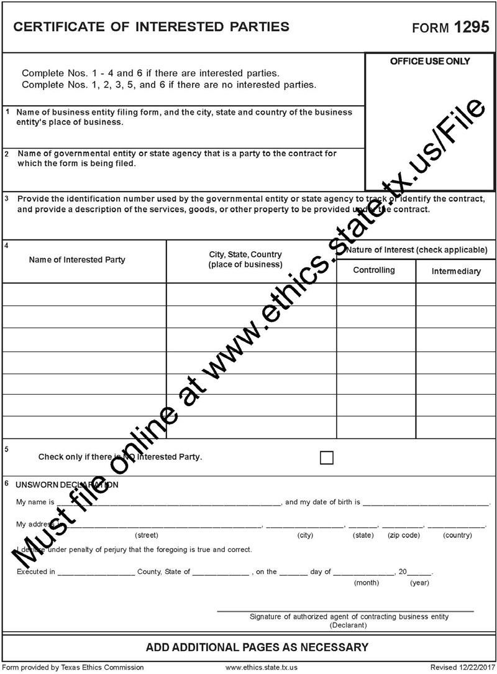

Senate Bill 252 Certification

On this day, I, Rick Elizondo, the Chief Financial Officer for the Gulf Coast Center, pursuant to Chapter 2252, Section 2252.152 of the Texas Government Code, certify that I did review the website list prepared, maintained, and made available to the Gulf Coast Center by the Comptroller of the State of Texas of companies known to have contracts with or provide supplies or services to Iran, Sudan or any foreign terrorist organization. I have ascertained that the below-named company is not contained on said list of companies that do business with Iran, Sudan or any Foreign Terrorist Organization.

RESPONDENT FILL OUT THE BELOW SECTION:

___________________________________
Company Name

___________________________________
RFQ or Vendor number

CERTIFICATION CHECK PERFORMED BY:

________________________________________
(signature)

________________________________________
Chief Financial Officer, Gulf Coast Center

________________________________________
Date

House Bill 89 Verification
I, (Person name), the undersigned representative of (Company or Business Name) (hereinafter referred to as Company) being an adult over the age of eighteen (18) years of age, after being duly sworn by the undersigned notary, do hereby depose and verify under oath that the company named-above, under the provisions of Subtitle F, Title 10, Government Code Chapter 2270:
  - Does not boycott Israel currently; and
  - Will not boycott Israel during the term of the contract the above-named Company, business or individual with the Gulf Coast Center/Connect Transit.

Pursuant to Section 2270.001, Texas Government Code:
            - “Boycott Israel” means refusing to deal with, terminating business activities with, or otherwise taking any action that is intended to penalize, inflict economic harm on, or limit commercial relations specifically with Israel, or with a person or entity doing business in Israel or in an Israeli-controlled territory, but does not include an action made for ordinary business purposes; and
            - “Company” means a for-profit sole proprietorship, organization, association, corporation, partnership, joint venture, limited partnership, limited liability partnership, or any limited liability company, including a wholly owned subsidiary, majority-owned subsidiary, parent company or affiliate of those entities or business associations that exist to make a profit.

DATE SIGNATURE OF COMPANY REPRESENTATIVE

STATE OF § COUNTY OF

On this day, BEFORE ME, the undersigned, personally appeared , the of Company, and personally known to me or proved to me on the basis of satisfactory evidence to be the individual whose name is subscribed to the within instrument and acknowledged to me that he/she executed the same in his/her capacity, and that by his/her signature on the instrument, the individual executed the instrument for purposes and consideration therein expressed.

GIVEN UNDER MY HAND AND SEAL OF OFFICE this day of , 2020.

[SEAL] NOTARY PUBLIC in and for the State of Texas

Contractor Payment Report Form

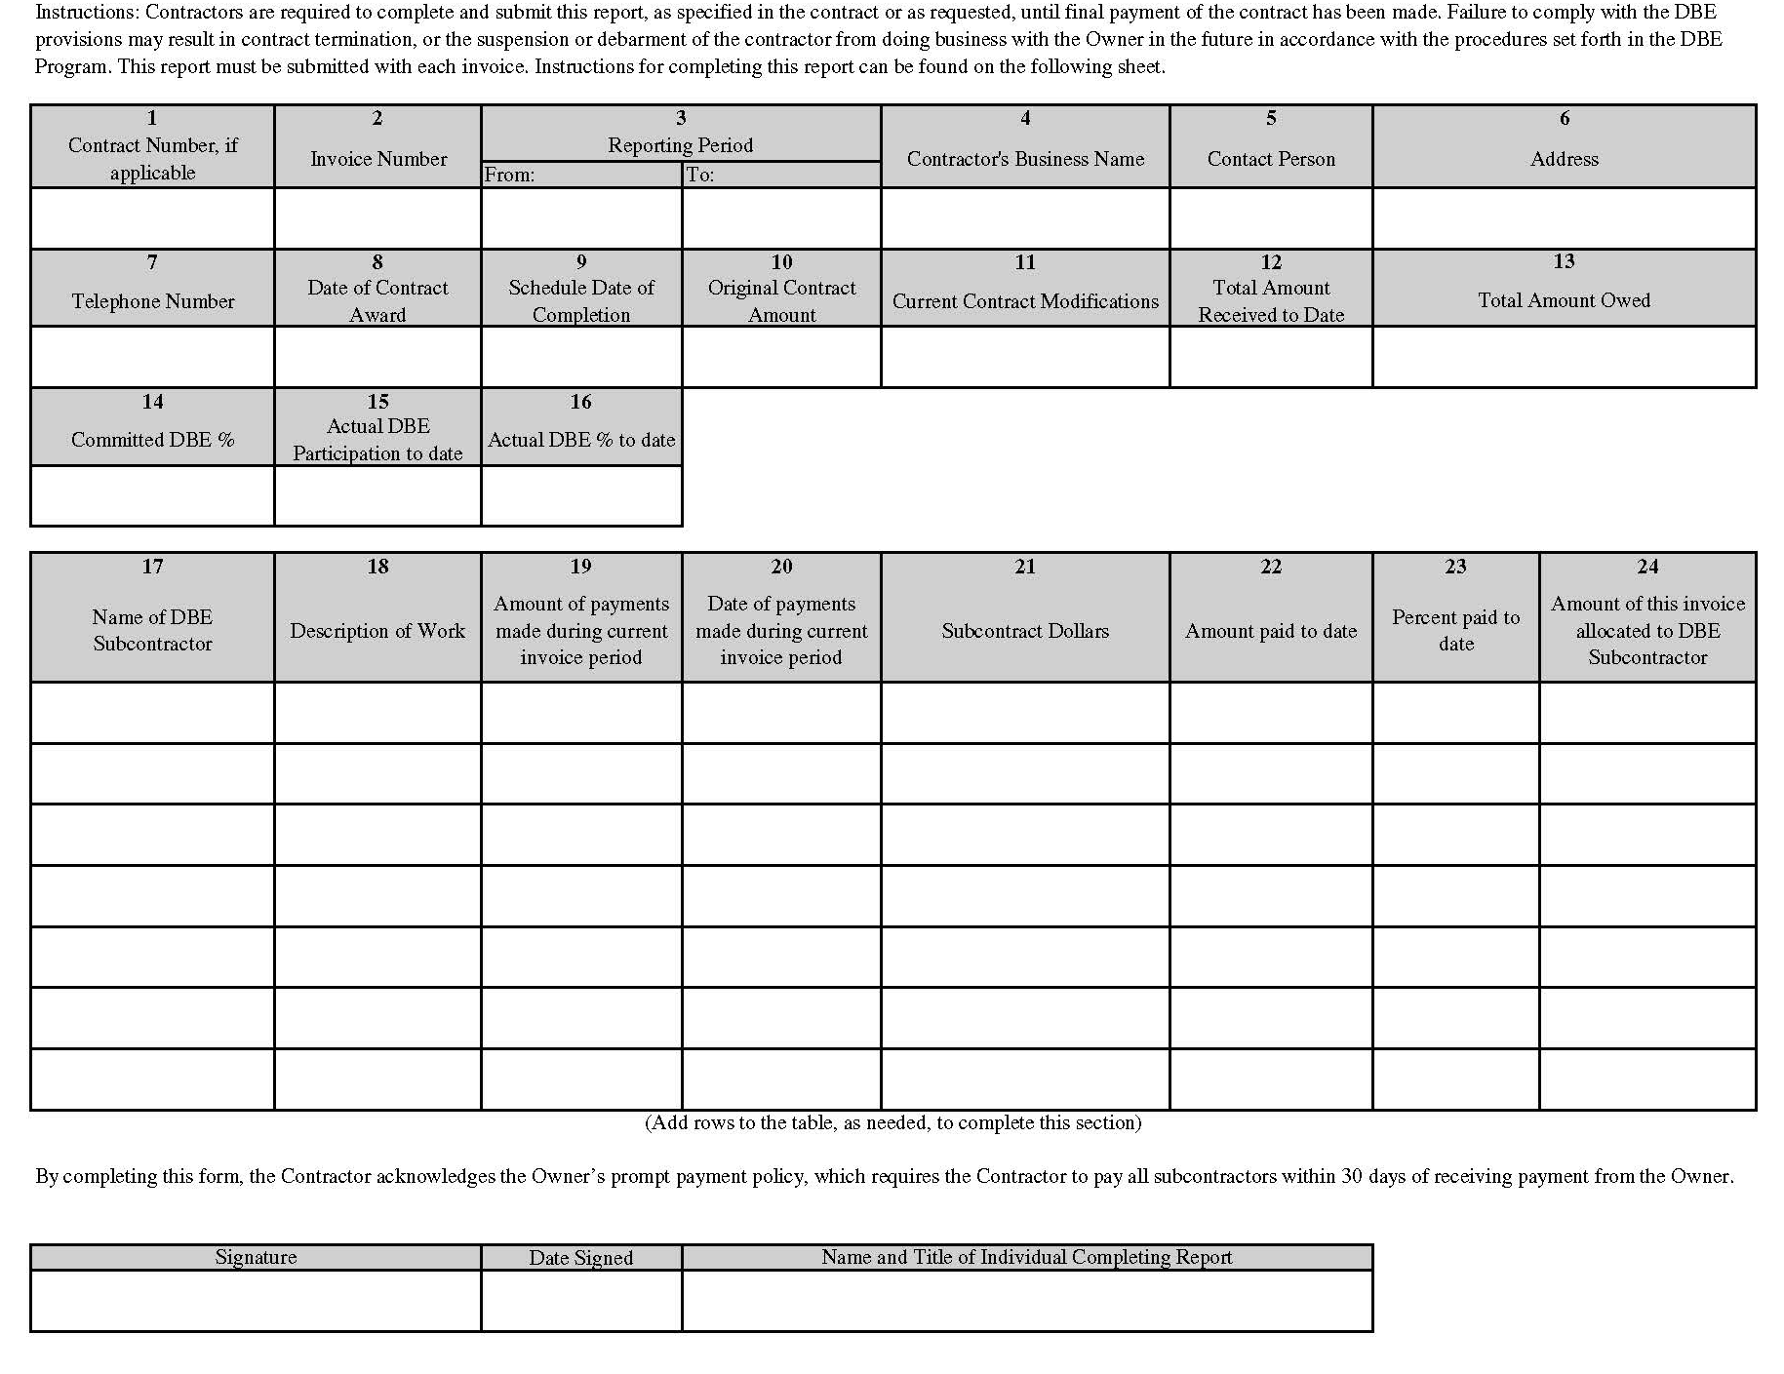

Exhibit F – TxDOT PTN 130 Form
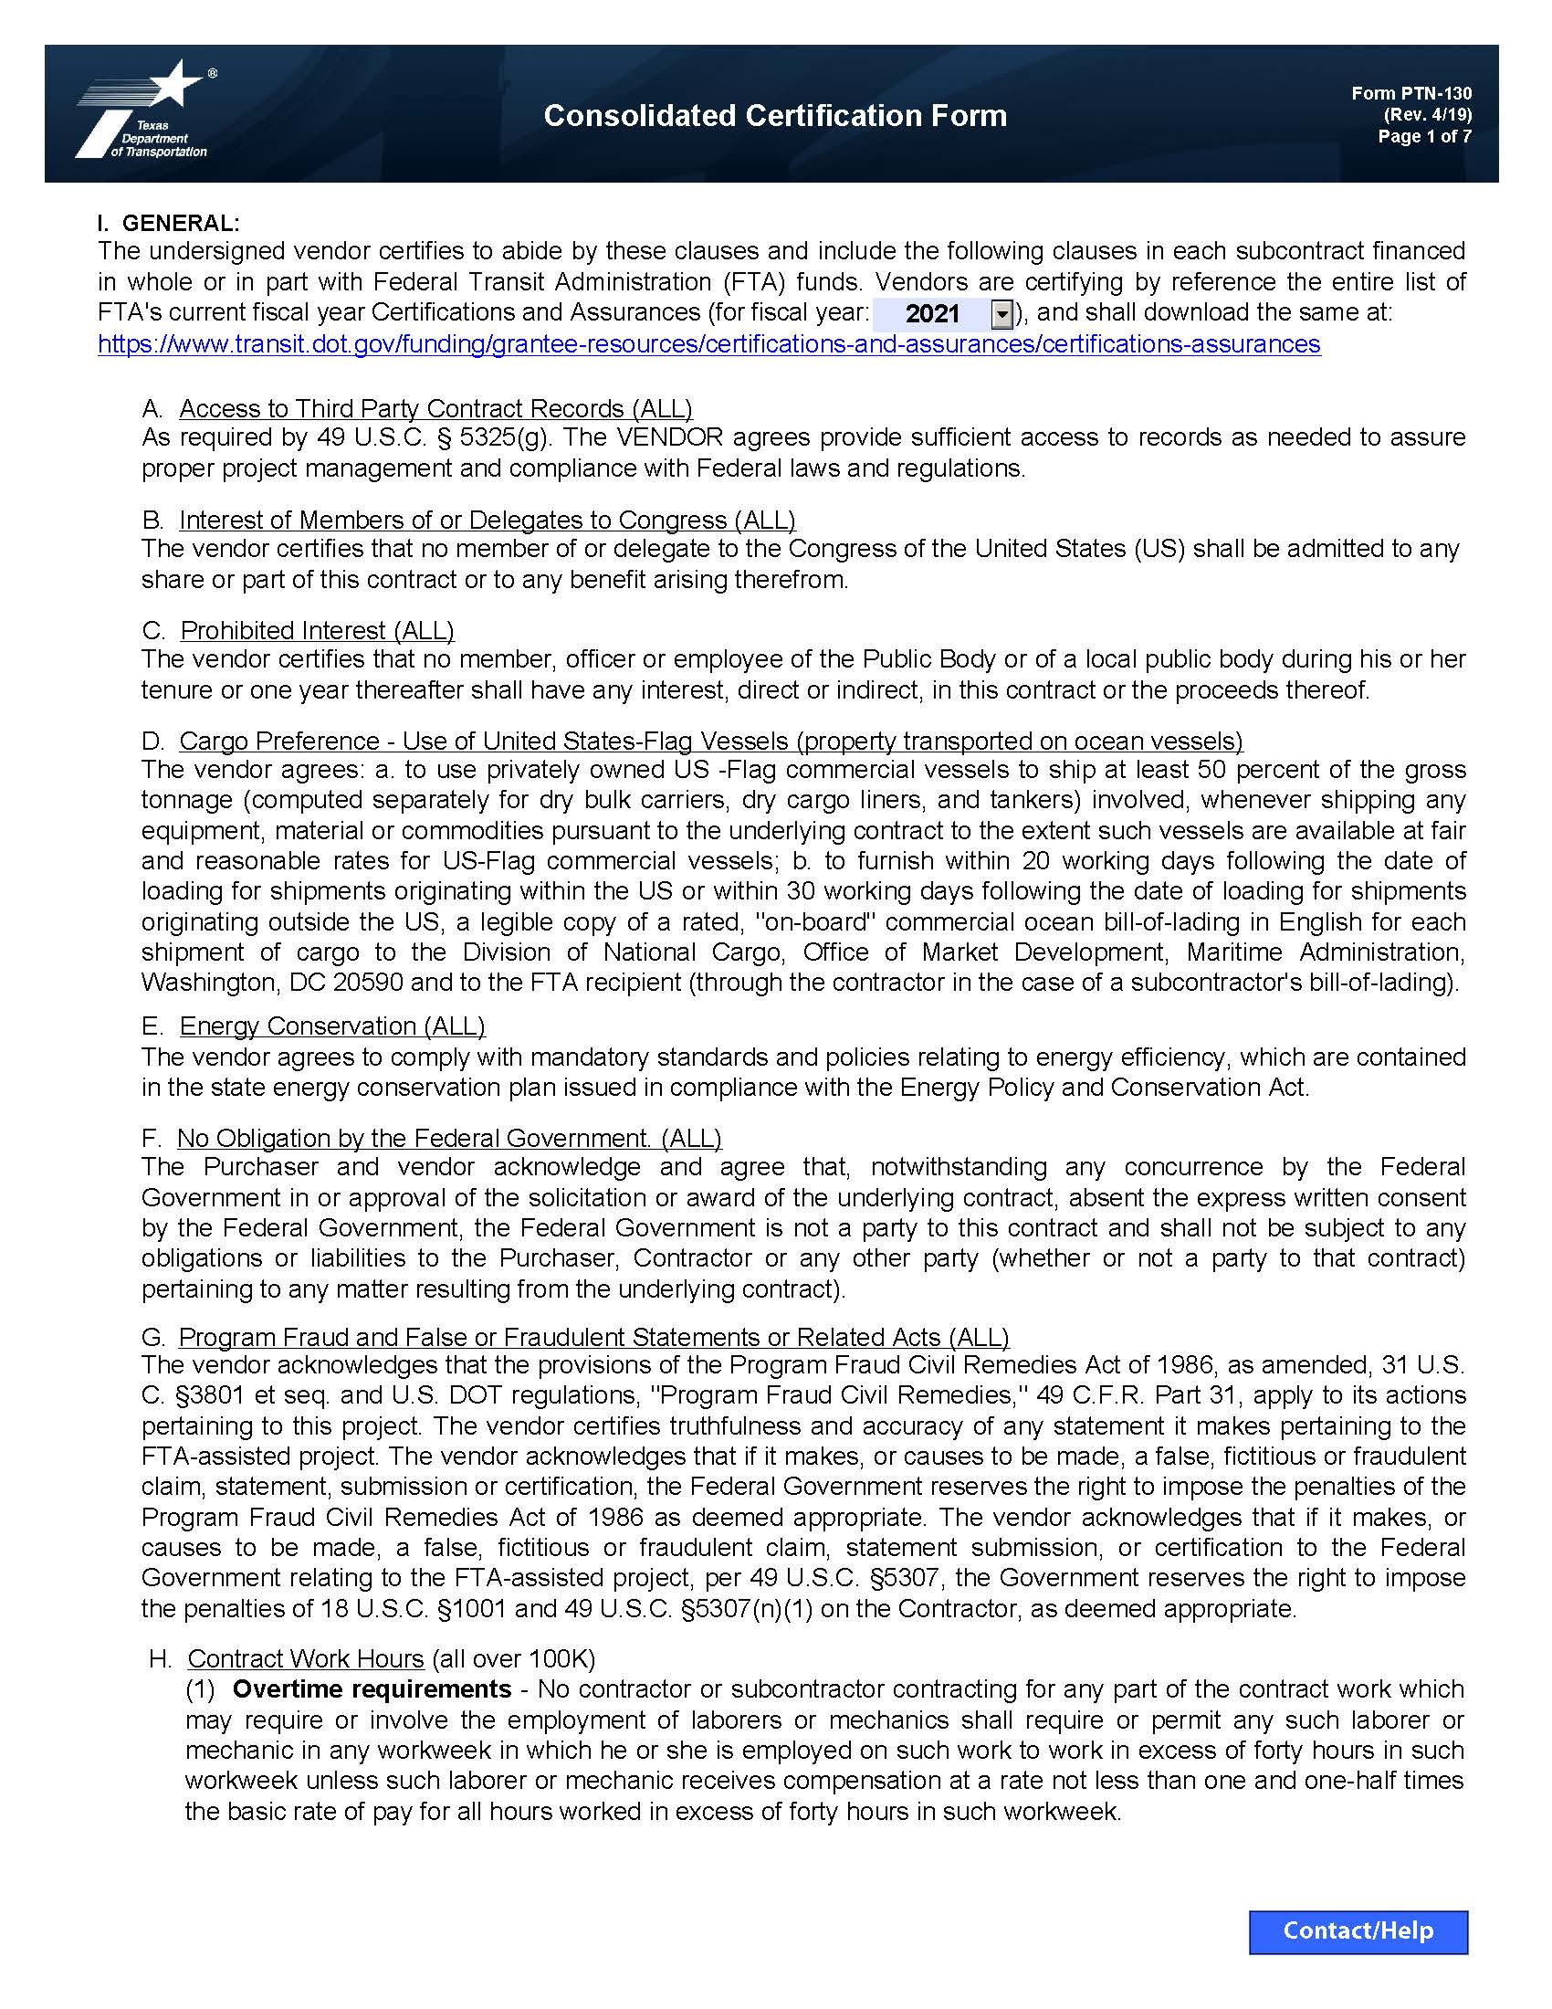

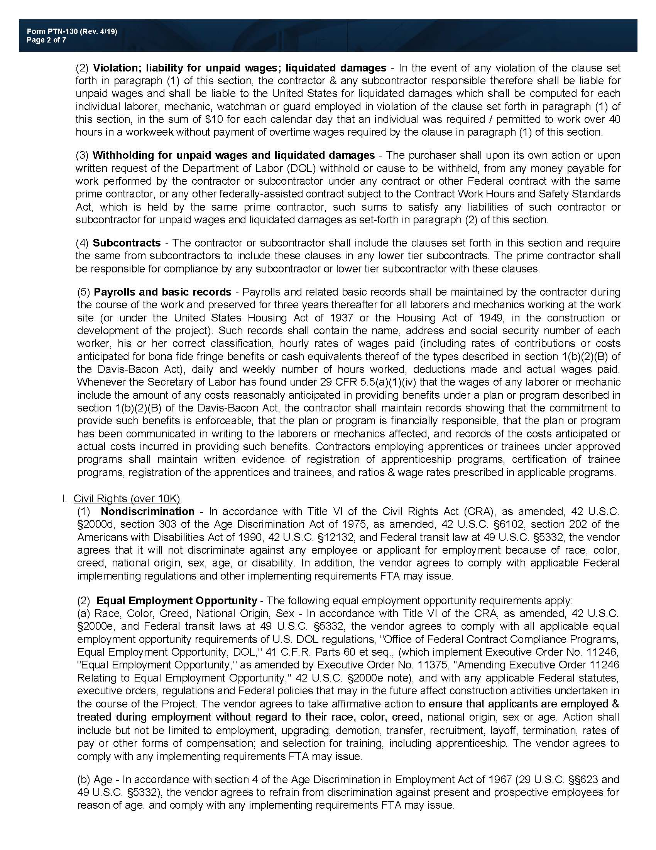
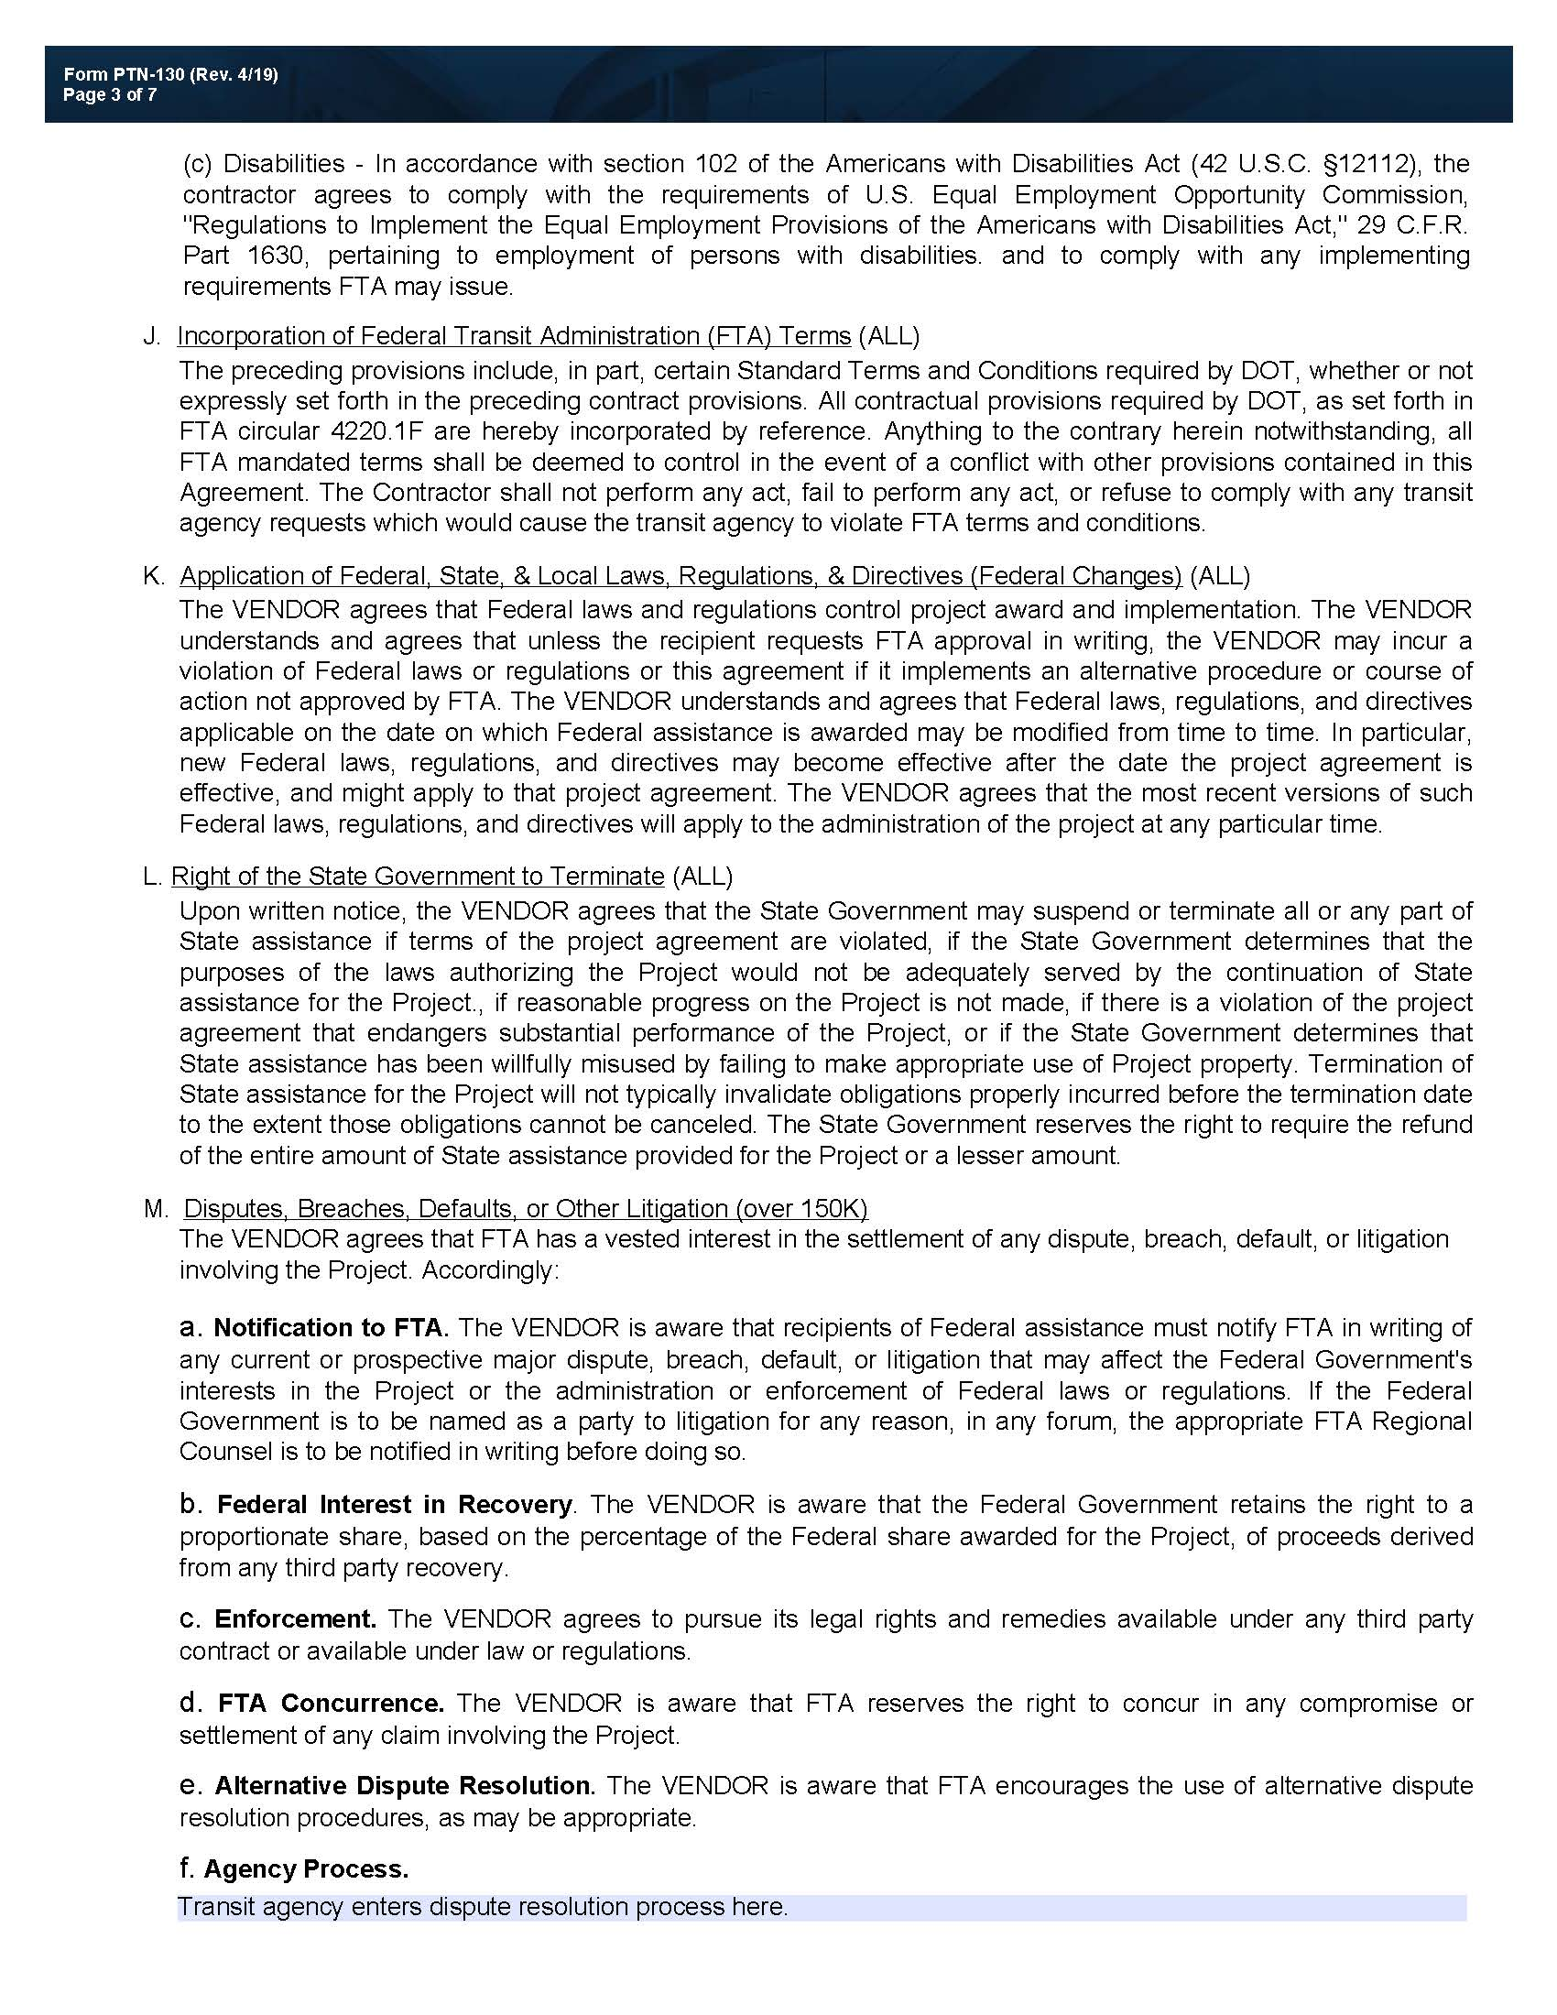
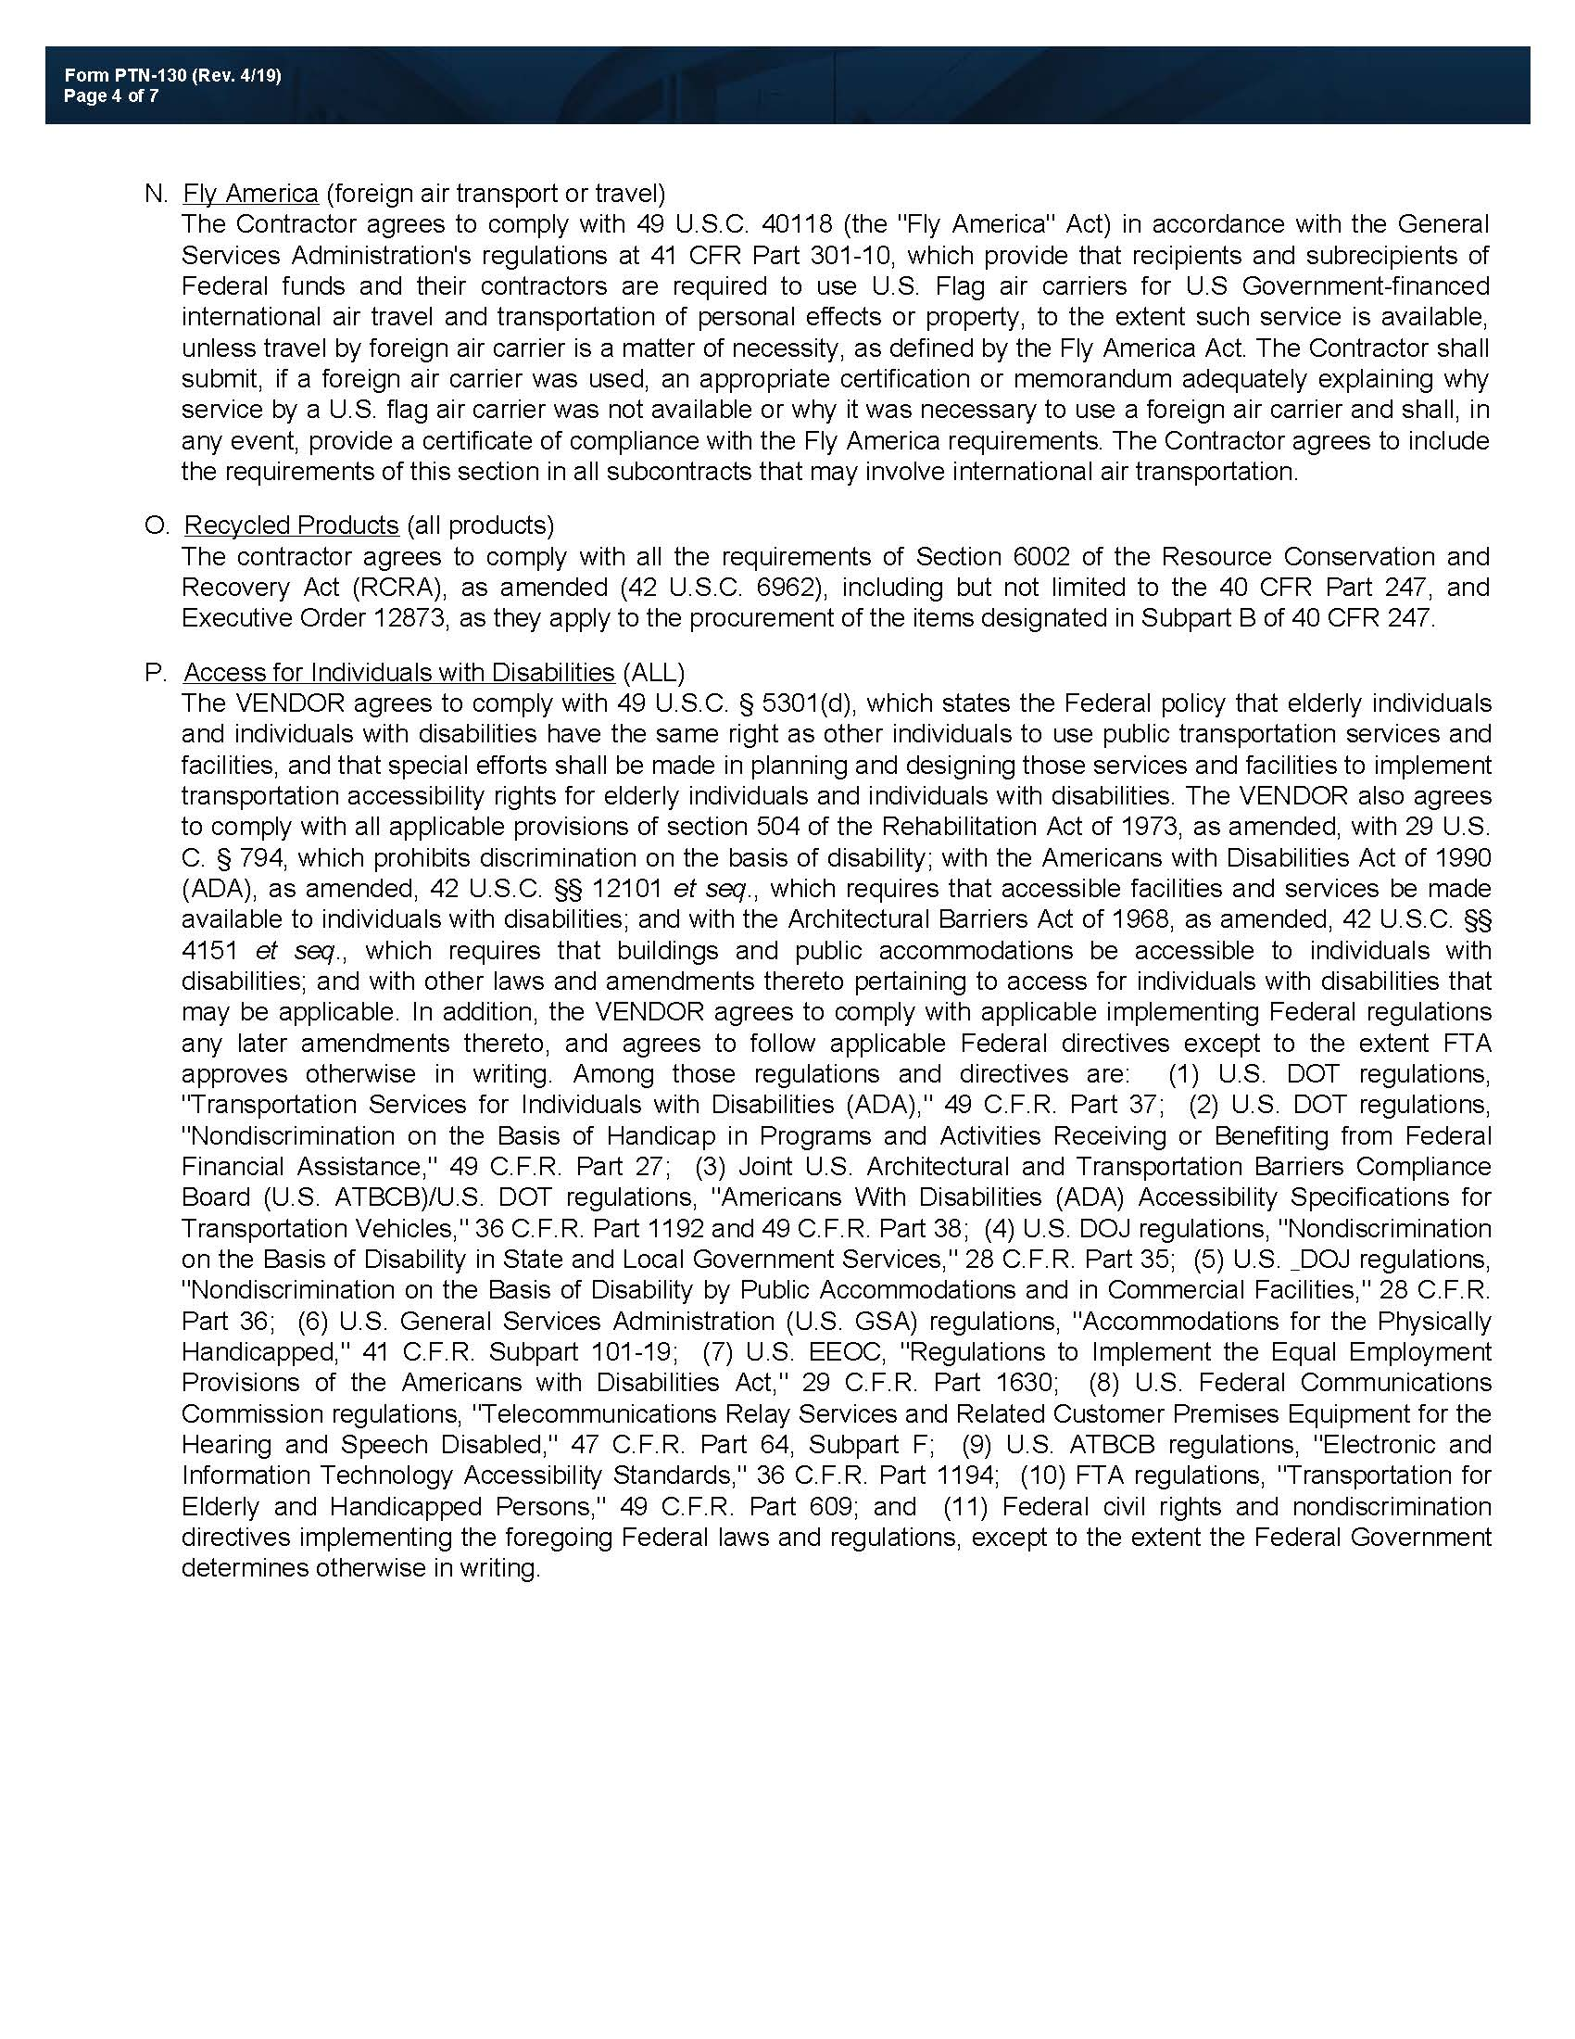
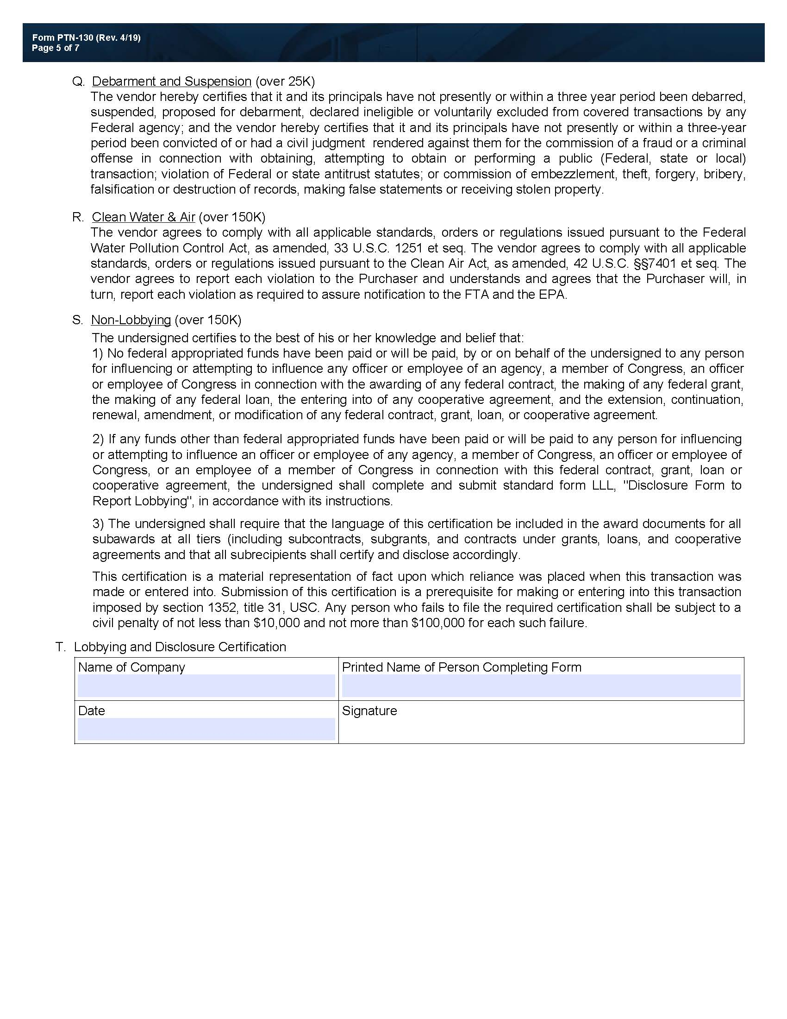
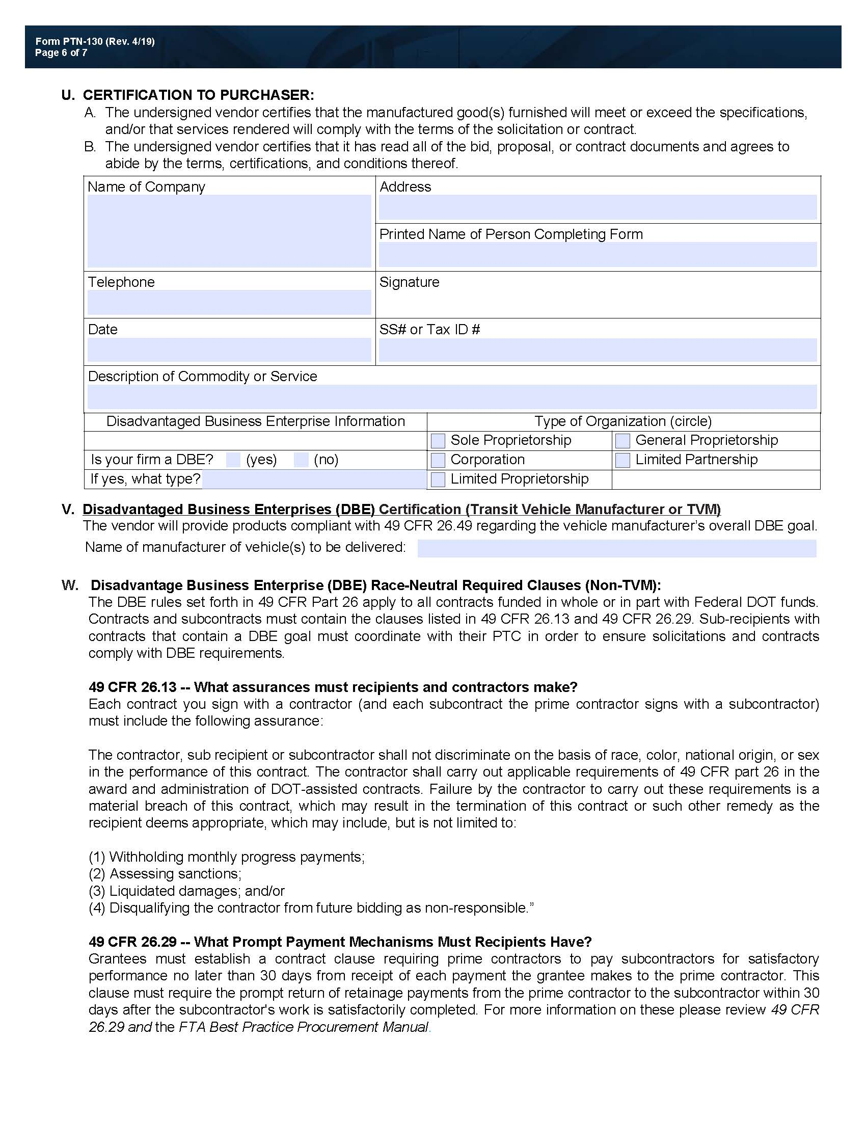

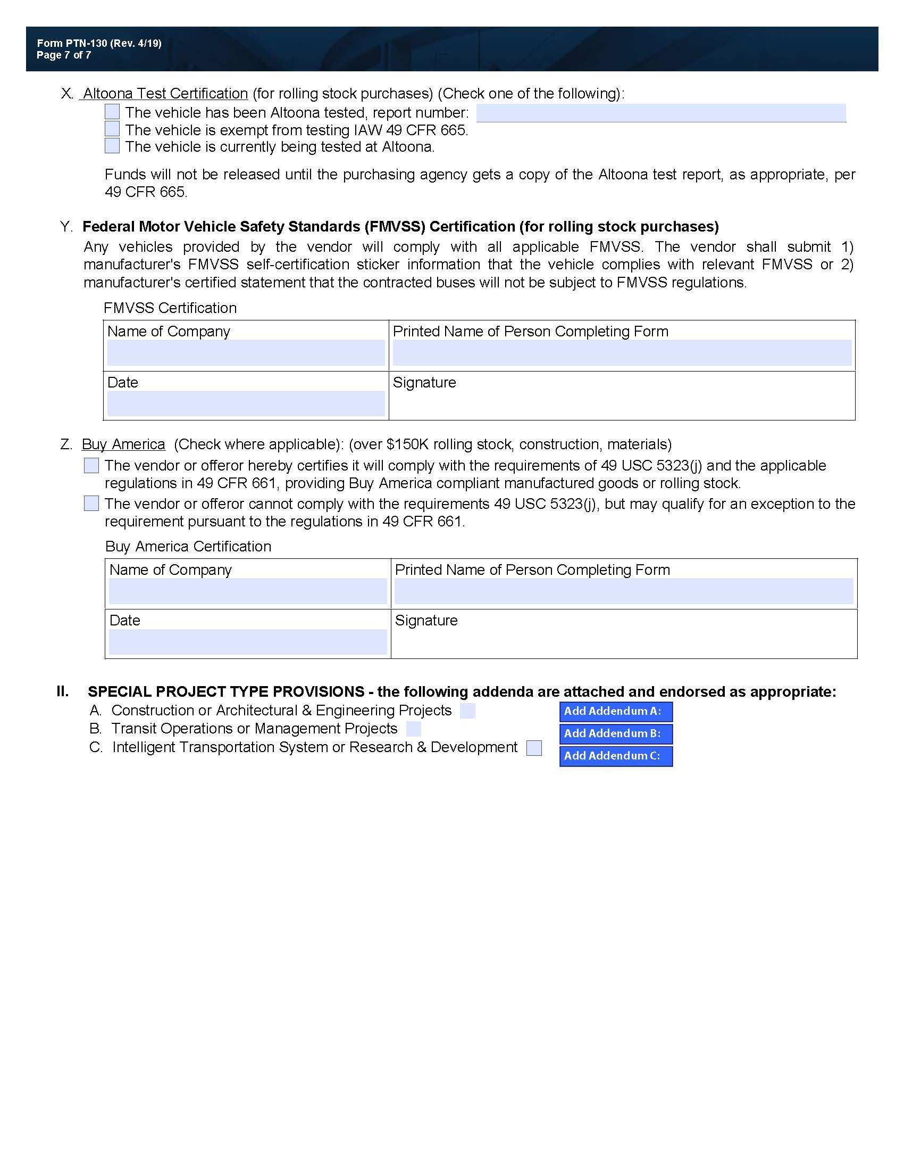

ExhiBit G – Acknowledgment of Addenda
Professional Design Services for Public Transit Provider
#2021 TRANSIT 001

The undersigned acknowledges receipt of the following addenda to the Center’s Request for Qualifications (insert number and date of each addendum). Attach each acknowledged addendum to this exhibit.

Addendum Number ________________________ Dated:__________________
Addendum Number ________________________ Dated:__________________
Addendum Number ________________________ Dated:__________________
Addendum Number ________________________ Dated:__________________
Addendum Number ________________________ Dated:__________________
Addendum Number ________________________ Dated:__________________
Addendum Number ________________________ Dated:__________________
Addendum Number ________________________ Dated:__________________

If Respondent fails to acknowledge receipt of all addenda, then the qualifications is considered non-responsive to the RFQ and the Center may reject Respondent’s SOQ.

Date: _________________________________________
Respondent: _________________________________________
Signature: _________________________________________
Print Name: _________________________________________
Title: _________________________________________

Exhibit H – Required Response Form

Include this form (or replica) in the firm’s qualifications package after the executive summary

Name of Respondent:

Physical address of
the principal
place of business:

Mailing Address:

Telephone:

Fax:

Email:

Print name of
Primary contact:

Signature:

Date:

